Maltalingua English Language School — language school in Malta

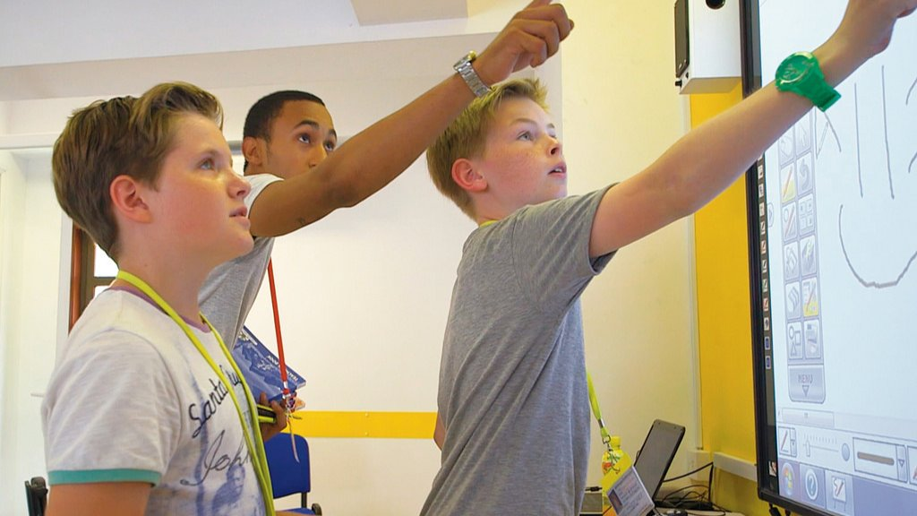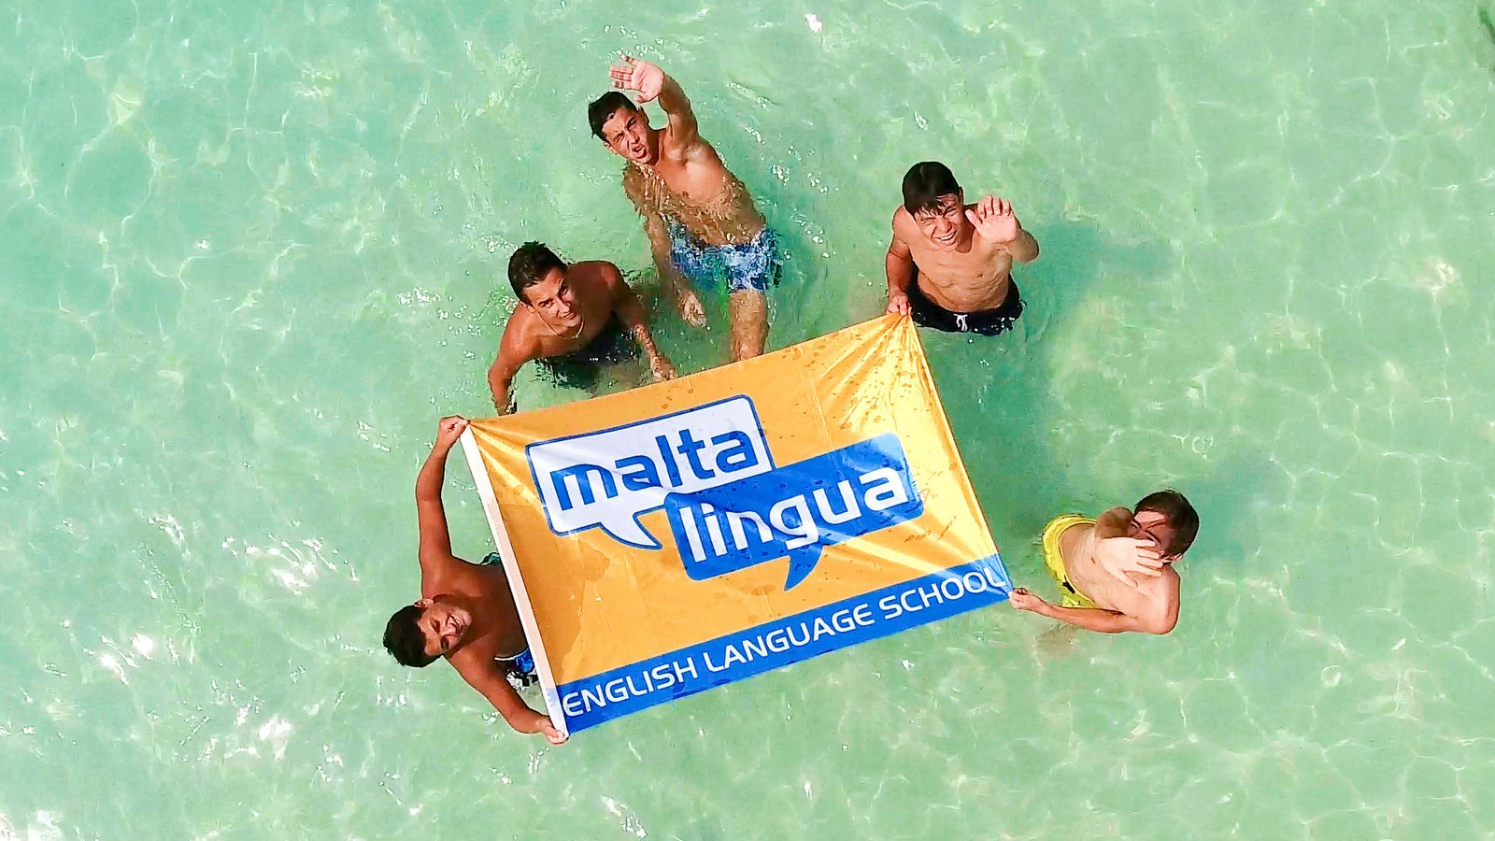

St Julian's, Мальта, from to age

Course intensity | 15
Accommodation | Residence
Room type | Twin
Bathroom facilities | En-suite
Meals | Breakfast, Lunch and Dinner
Excursions per week | 5
Weekday excursions | 3
Full day excursions | 2

Description

Why choose this program

Infrastructure

Sport infrastructure

Hobbies and clubs

What else included in the program price

Recommended arrival city

Luqa

Sample timetable
 | Morning | Afternoon | Evening
Day 1 | English Lessons (4 per day) | Valletta Tour & 5D Experience | Welcome BBQ
Day 2 | English Lessons (4 per day) | Bowling | Games Night
Day 3 | English Lessons (4 per day) | Maltalingua Beach Club | International Junior Student Party
Day 4 | English Lessons (4 per day) | Sliema Shopping | Go-Karting
Day 5 | English Lessons (4 per day) | Golden Bay | Riviera Beach By Night
Day 6 | Daytrip to Comino | Farewell Party | Farewell Party
Day 7 | Recommended Transfer Day | Gozo Tour | Gozo Tour

For booking please go to www.travelclass.org

