Chaucer College — English language school in the UK

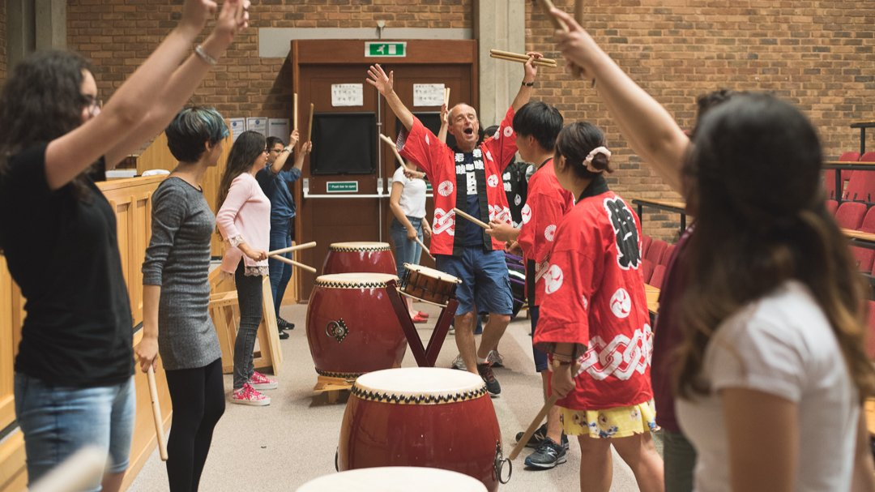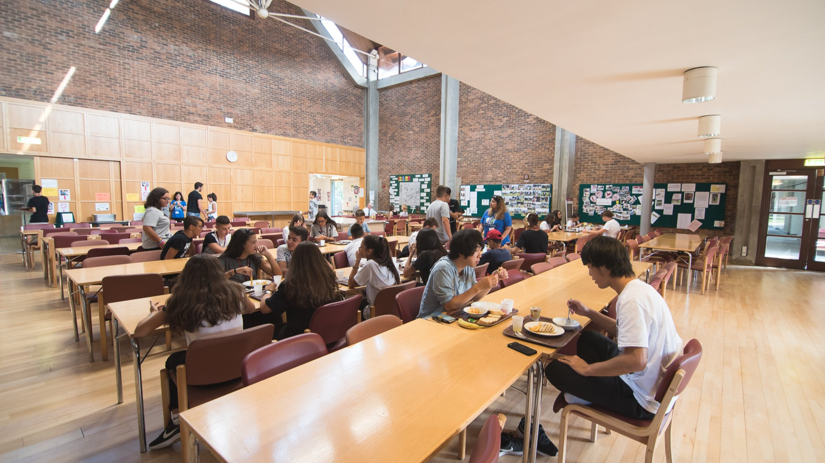

Canterbury CT2 7LJ, UK, from 10 to 17 age

Course intensity | 20
Accommodation | Campus
Room type | Twin
Bathroom facilities | Shared
Meals | Breakfast, Lunch and Dinner
Excursions per week | 2
Weekday excursions
Full day excursions | 2

Description

Why choose this program

Infrastructure

Sport infrastructure

Hobbies and clubs

What else included in the program price

Recommended arrival city

Лондон

Sample timetable
 | Morning | Afternoon | Evening
Day 1 | Arrival | Free time | Welcome BBQ
Day 2 | Lesson | Canterbury tour | Disco
Day 3 | Lesson | Project Afternoon | On-site activities
Day 4 | Lesson | Project Afternoon | On-site activities
Day 5 | Lesson | Half day excursion | On-site activities
Day 6 | FULL DAY EXCURSION | FULL DAY EXCURSION | Movie night
Day 7 | Lesson | Out and about English | On-site activities

For booking please go to www.travelclass.org

