did deutsch institut Munich — summer school in Germany

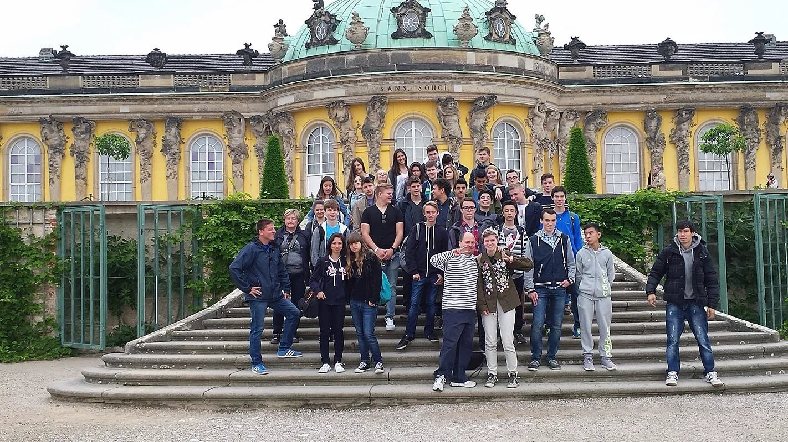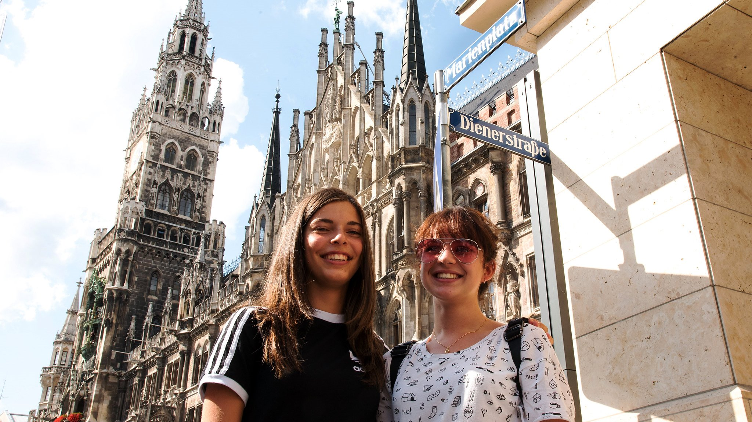

Landsberger Straße 338, München, Deutschland, from 14 to 17 age

Course intensity | 15
Accommodation | Residence
Room type | Quadraple
Bathroom facilities | En-suite
Meals | Breakfast, Lunch and Dinner
Excursions per week | 5
Weekday excursions | 4
Full day excursions | 1

Description

Why choose this program

Infrastructure

Sport infrastructure

Hobbies and clubs

What else included in the program price

Recommended arrival city

Мюнхен

Sample timetable
 | Morning | Afternoon | Evening
Day 1 | Arrival | House tour | Icebreaker games
Day 2 | Classes | Entertainment (i.e., Sea Life or bouldering) | Munich by night
Day 3 | Classes | City exploration (i.e., Cathedral of Our Lady and shopping) | Movie night
Day 4 | Classes | Museum visit (i.e., German Museum or Pinakothek) | Time for friends
Day 5 | Classes | City exploration (i.e., university and shopping) | Games and sports
Day 6 | Classes | Behind the Scenes (i.e., Allianz Arena or BMW factory) | Party
Day 7 | Full day excursion to Nuremberg/Regensburg/Salzburg/Neuschwanstein Castle/Lindau/Garmisch-Partenkirchen | Full day excursion to Nuremberg/Regensburg/Salzburg/Neuschwanstein Castle/Lindau/Garmisch-Partenkirchen | Time for friends

For booking please go to www.travelclass.org

