UKLC Bristol Badminton School — language school in the UK

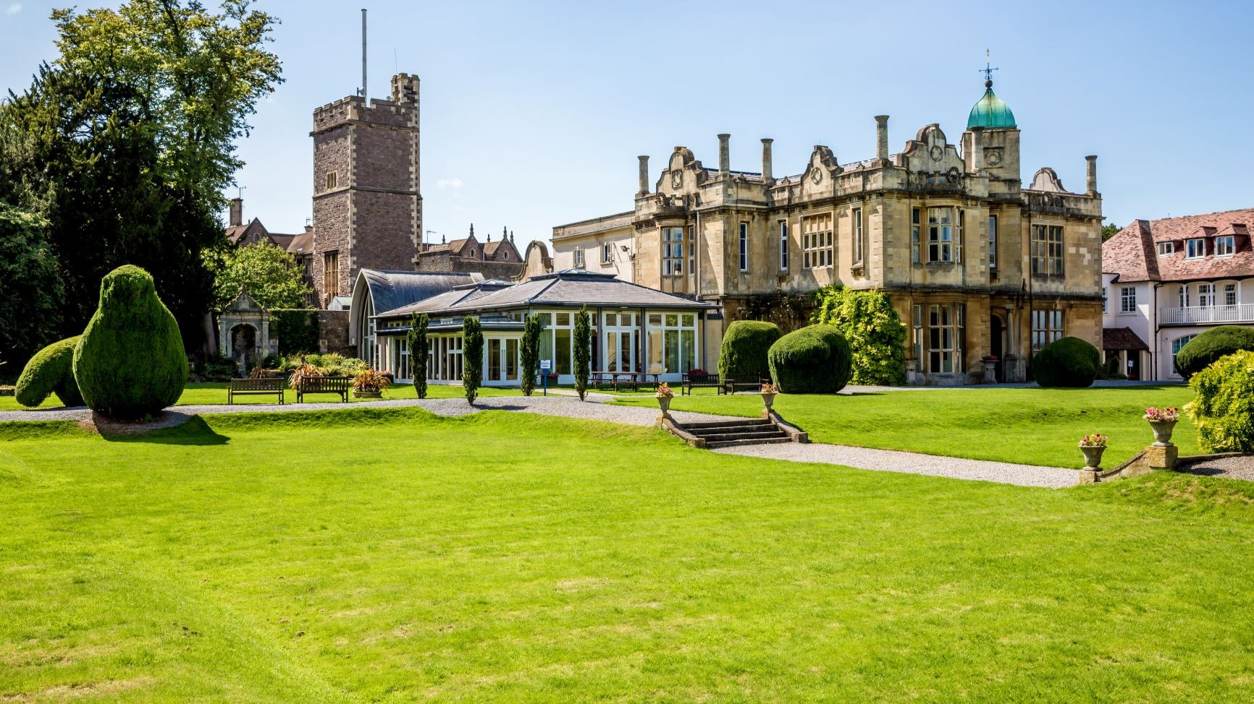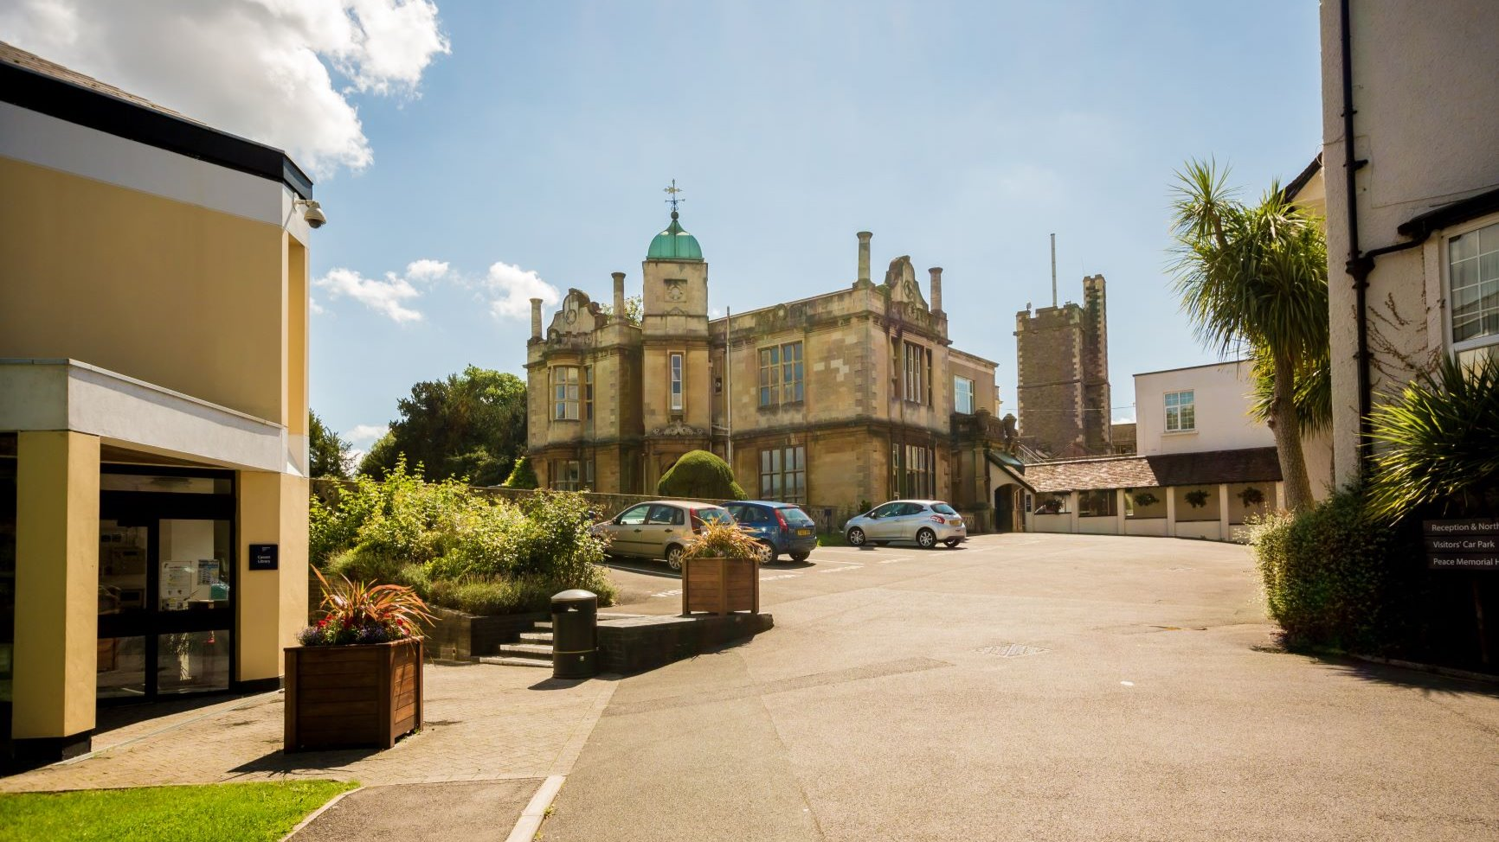

Badminton School, Bristol, UK, from 11 to 15 age

Course intensity | 15
Accommodation | Host family
Room type | Twin
Bathroom facilities | Shared
Meals | Breakfast, Lunch and Dinner
Excursions per week | 3
Weekday excursions | 3
Full day excursions | 0

Description

Why choose this program

Infrastructure

Sport infrastructure

Hobbies and clubs

What else included in the program price

Recommended arrival city

Лондон

Sample timetable
 | Morning | Afternoon | Evening
Day 1 | Arrival | Multi Activity or Chosen Programme | Evening With Host Family
Day 2 | English Lessons | Bristol Walking Tour and Orientation | Evening With Host Family
Day 3 | English Lessons | Sports & Activities | Evening With Host Family
Day 4 | English Lessons | Clifton Suspension Bridge | Evening With Host Family
Day 5 | English Lessons | Bristol Photography Workshop | Evening With Host Family
Day 6 | English Lessons | Bristol Museum | Evening With Host Family
Day 7 | Departure

For booking please go to www.travelclass.org

