ALPADIA Leysin — summer school in Switzerland

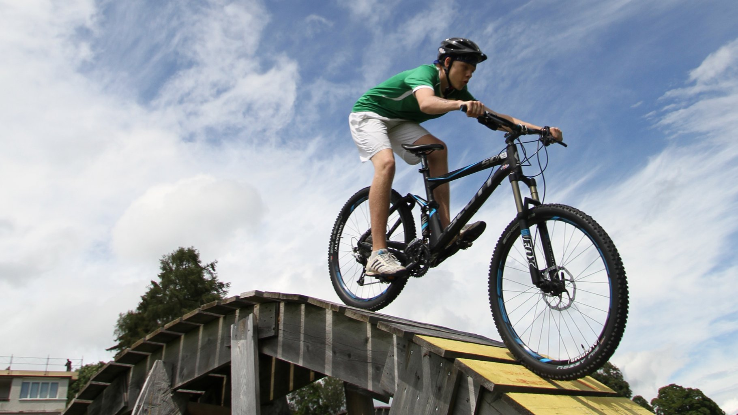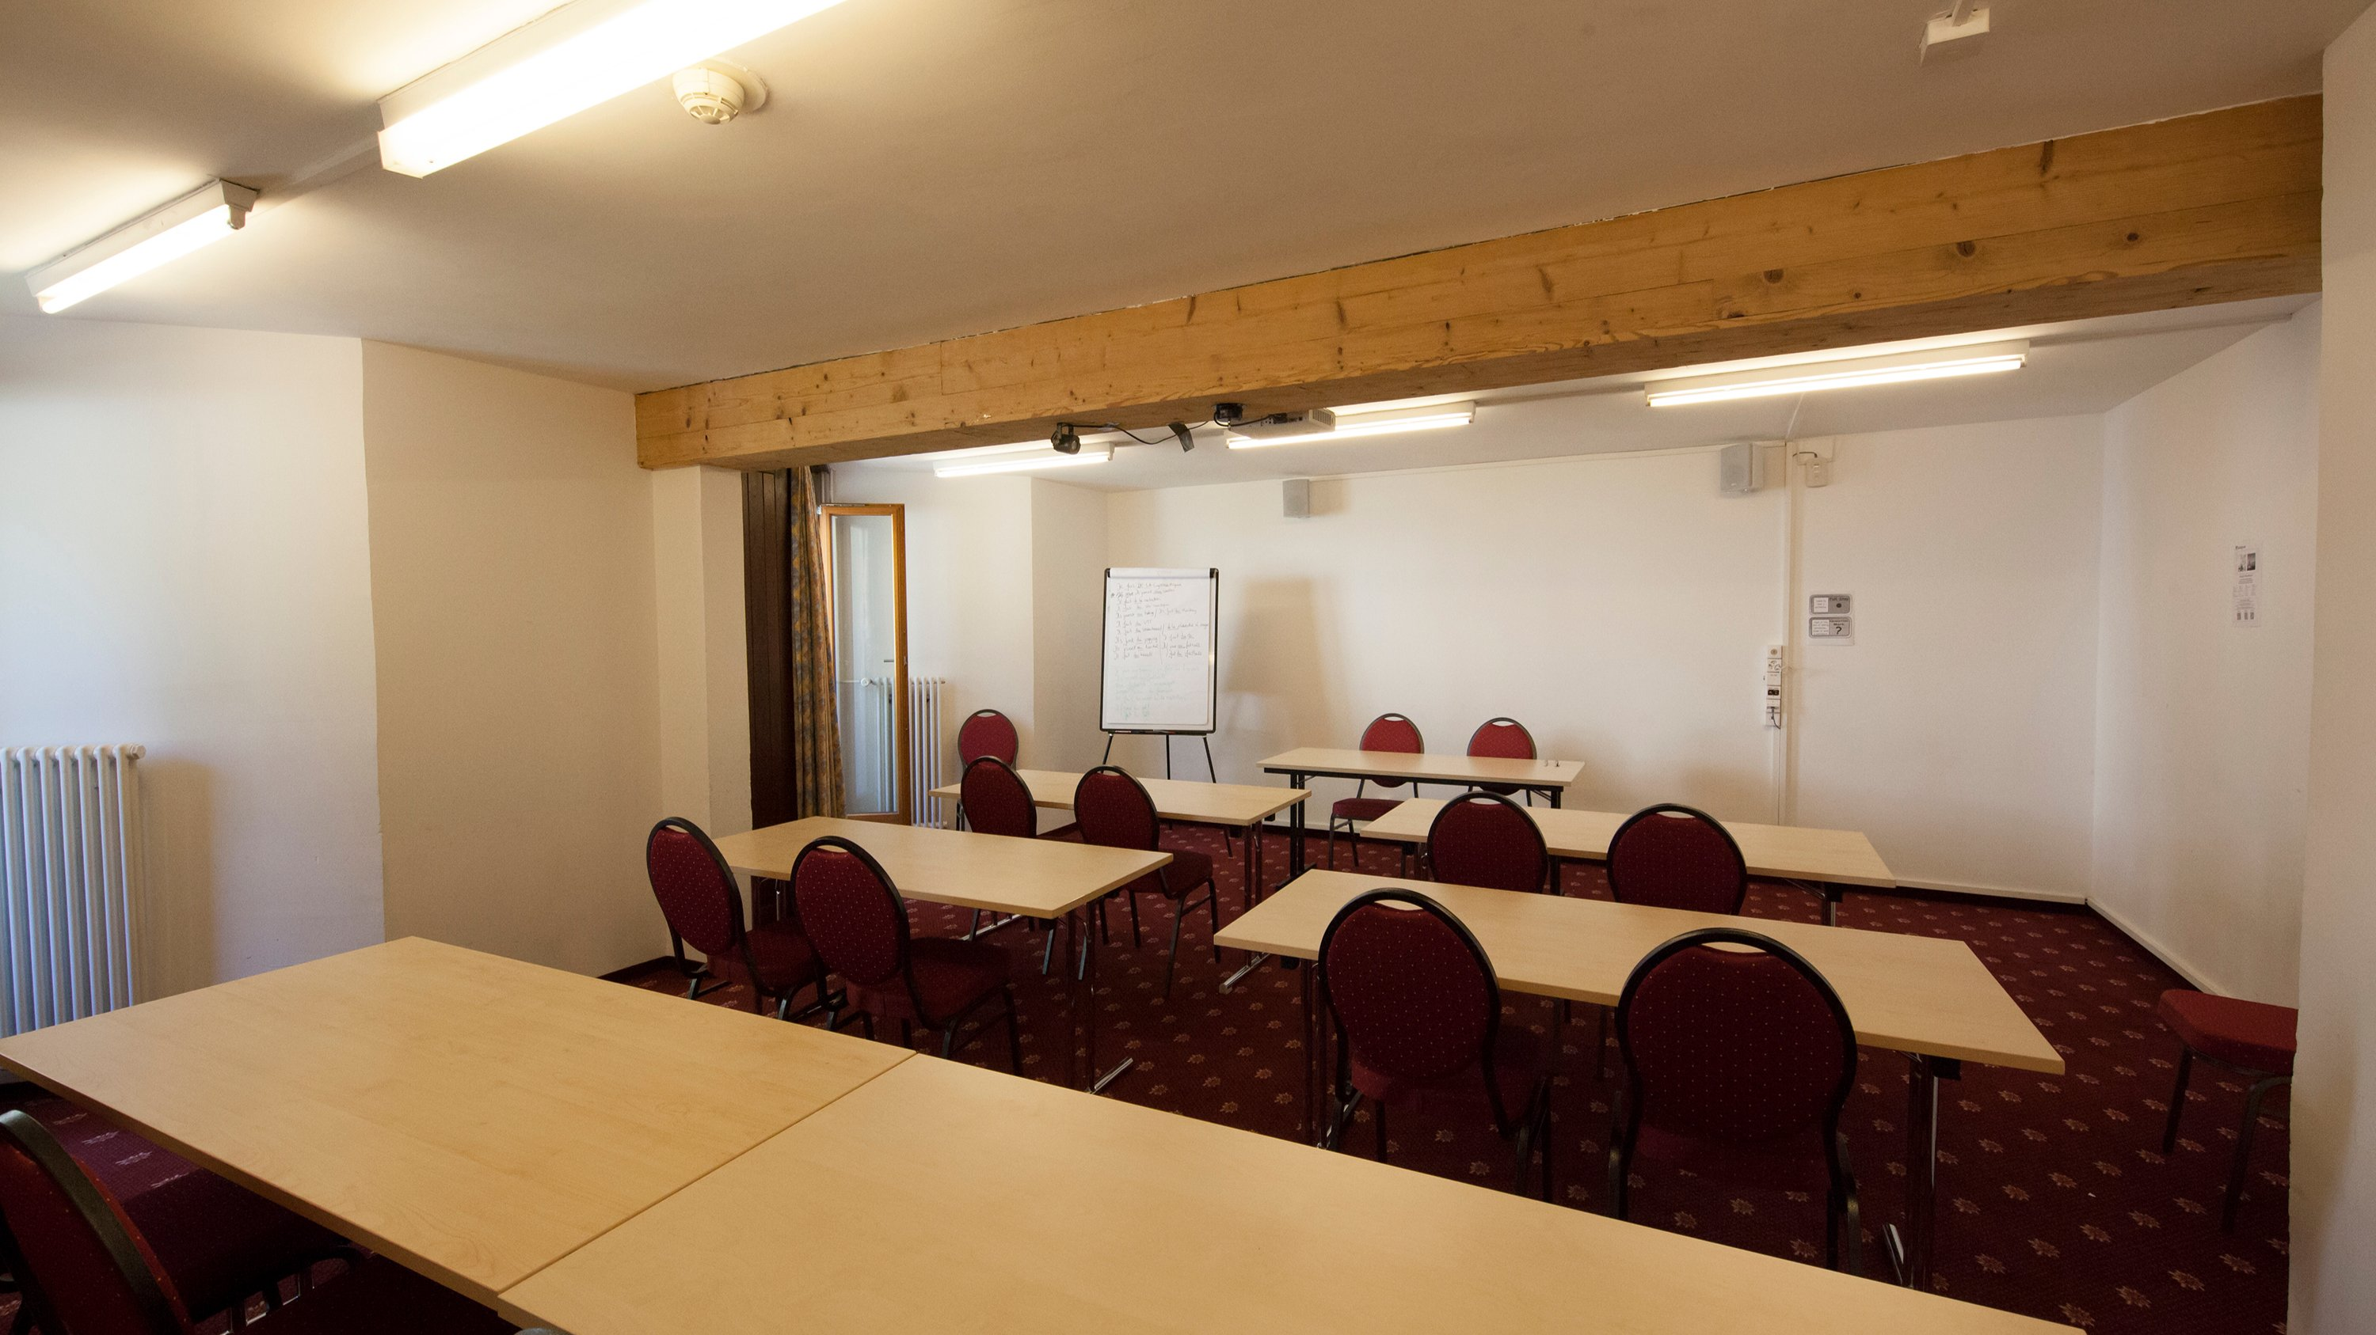

Central Résidence, hôtel, Leysin, Switzerland, from 8 to 17 age

Course intensity | 20
Accommodation | Hotel
Room type | Quadraple
Bathroom facilities | En-suite
Meals | Breakfast, Lunch and Dinner
Excursions per week | 3
Weekday excursions | 1
Full day excursions | 2

Description

Why choose this program

Infrastructure

Sport infrastructure

Hobbies and clubs

What else included in the program price

Recommended arrival city

Женева

Sample timetable
 | Morning | Afternoon | Evening
Day 1 | Arrival day | Registration | Welcome party
Day 2 | Classes | Package activities | Sports tournament
Day 3 | Classes | Package activities | Olympic games
Day 4 | Classes | Excursion to Adventure Park | BBQ
Day 5 | Classes | Package activities | Movie night
Day 6 | Classes | Package activities | Disco party
Day 7 | Excursion to Chillon Castle & Montreux | Excursion to Chillon Castle & Montreux | Free evening

For booking please go to www.travelclass.org

