AIP Language Institute Valencia — language school in Spain

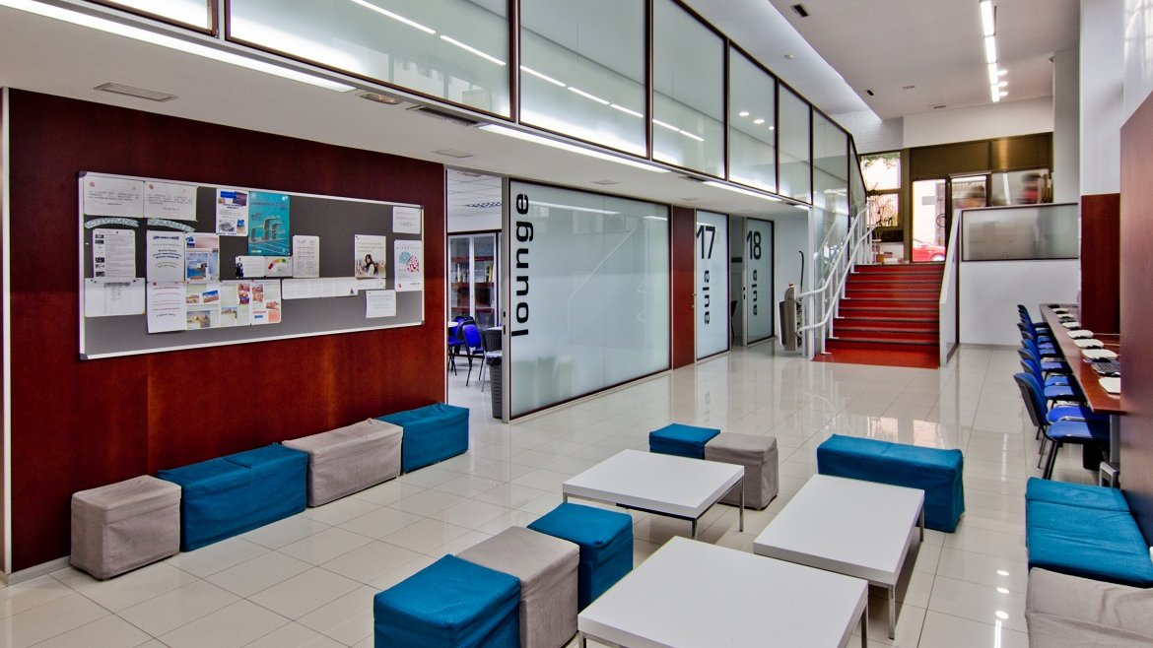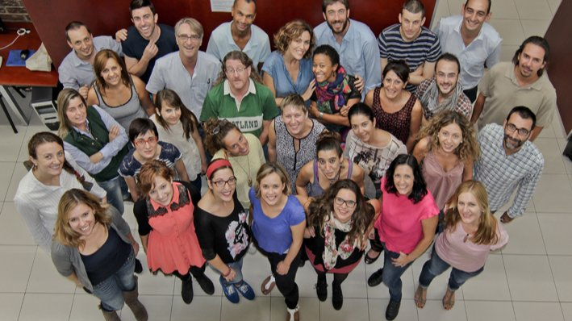

Calle el Bachiller 7, Valencia, España, from 12 to 18 age

Course intensity | 15
Accommodation | Residence
Room type | Twin
Bathroom facilities | En-suite
Meals | Breakfast, Lunch and Dinner
Excursions per week | 3
Weekday excursions | 2
Full day excursions | 1

Description

Why choose this program

Infrastructure

Sport infrastructure

Hobbies and clubs

What else included in the program price

Recommended arrival city

Валенсия

Sample timetable
 | Morning | Afternoon | Evening
Day 1 | Arrival | Arrival | Homestay
Day 2 | Lessons | Town tour | Homestay
Day 3 | Lessons | Activities | Scavenger hunt
Day 4 | Lessons | Activities | Homestay
Day 5 | Lessons | Local visit to Fine Arts Museum/Palace of Marqués de Dos Aguas/Bullfighting Museum/ football stadium | Homestay
Day 6 | Lessons | Local visit to Fine Arts Museum/Palace of Marqués de Dos Aguas/Bullfighting Museum/ football stadium | Homestay
Day 7 | Full-day excursion | Full-day excursion | Homestay

For booking please go to www.travelclass.org

