ATC Maynooth University — language school in Ireland

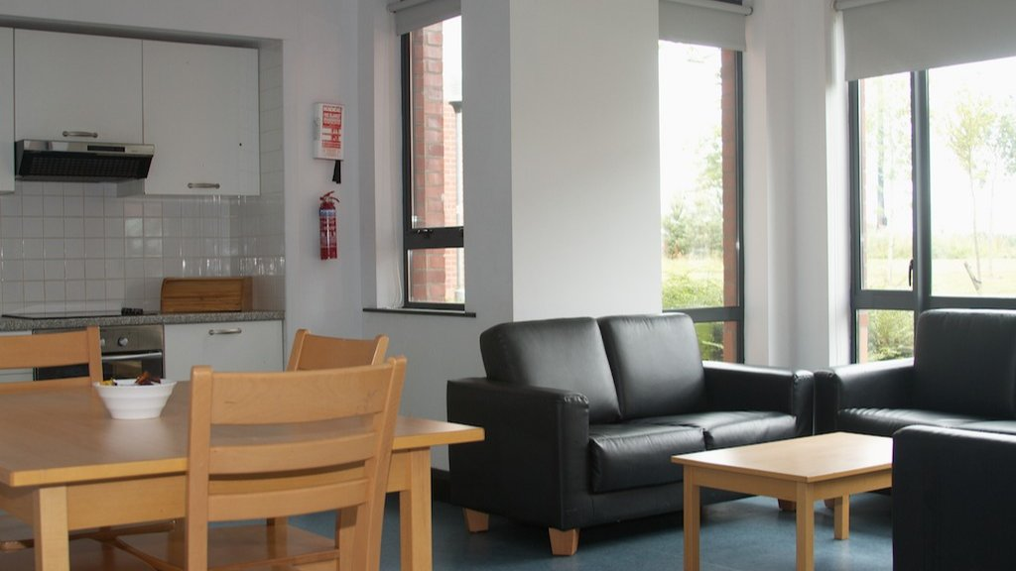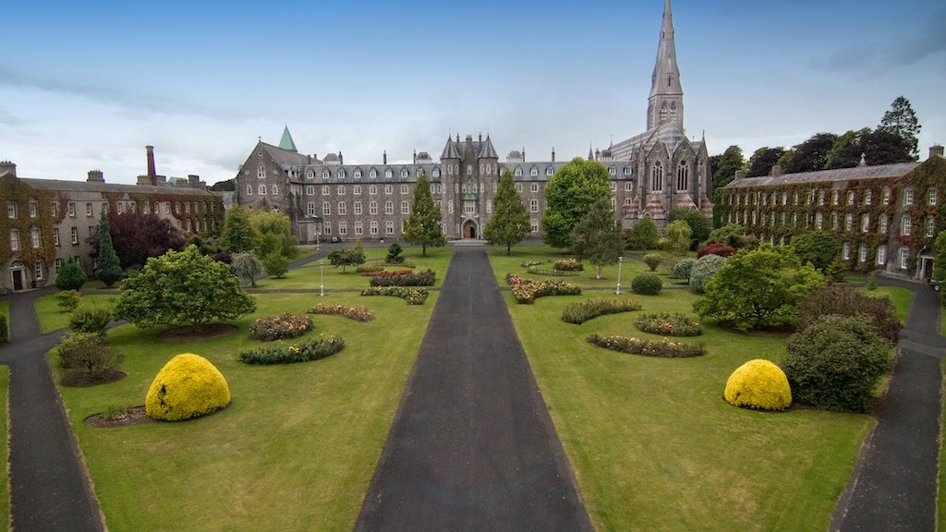

Maynooth, County Kildare, Ireland, from 11 to 17 age

Course intensity | 18
Accommodation | Campus
Room type | Single
Bathroom facilities | En-suite
Meals | Breakfast, Lunch and Dinner
Excursions per week | 2
Weekday excursions | 1
Full day excursions | 1

Description

Why choose this program

Infrastructure

Sport infrastructure

Hobbies and clubs

What else included in the program price

Recommended arrival city

Дублин

Sample timetable
 | Morning | Afternoon | Evening
Day 1 | Arrival Day | Introduction to ATC Staff, campus and other students | Disco
Day 2 | English Classes | ATC Projects - Gamezone | Fashion Show
Day 3 | English Classes | Trip to Chocolate Factory with ATC Staff and by private transport | Irish Night
Day 4 | English Classes | World of Work / Conversation Club | Film Night
Day 5 | English Classes | ATC Projects Photography with ATC Team | Gumball Challenge
Day 6 | English Classes | ATC Projects Gamezone with ATC Team | Giant Twister
Day 7 | Dublin City Centre | Dublin City Centre | Talent Show
Day 8 | Free day
Day 9 | English Classes | ATC Projects | Games
Day 10 | English Classes | ATC Projects | Disco
Day 11 | English Classes | Half day excursion | Quiz
Day 12 | English Classes | ATC Projects | Fashion Show
Day 13 | English Classes | ATC Projects | Karaoke
Day 14 | Full day excrusion | Full day excrusion | Full day excrusion

For booking please go to www.travelclass.org

