Irish College of English — language school in Ireland

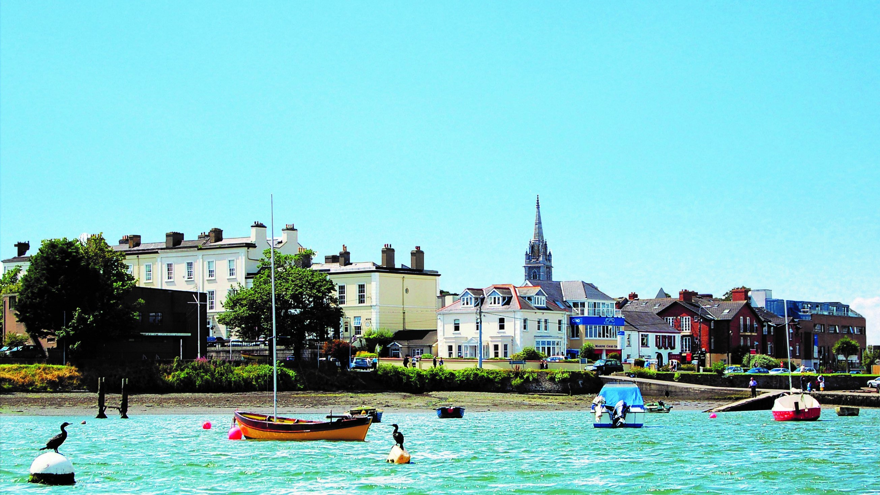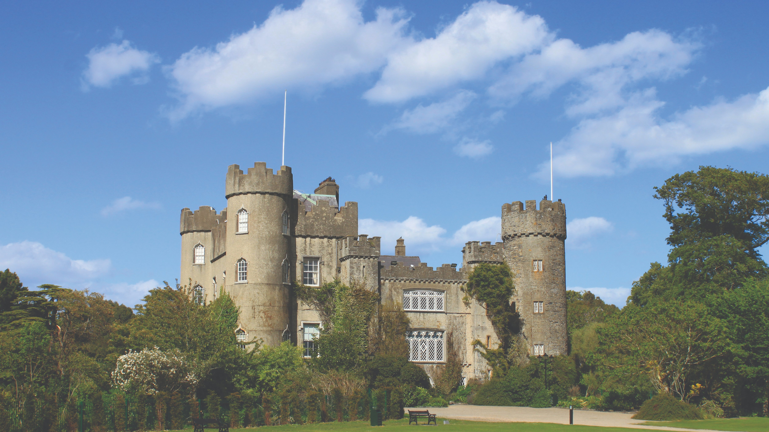

6 Church Road, Malahide, County Dublin, Ireland, from 11 to 17 age

Course intensity | 15
Accommodation | Host family
Room type | Twin
Bathroom facilities | Shared
Meals | Breakfast, Lunch and Dinner
Excursions per week | 6
Weekday excursions | 5
Full day excursions | 1

Description

Why choose this program

Infrastructure

Sport infrastructure

Hobbies and clubs

What else included in the program price

Recommended arrival city

Дублин

Sample timetable
 | Morning | Afternoon | Evening
Day 1 | English Classes | Dublin City Professional Walking Tour | Free Time with Host Family or Friends
Day 2 | English Classes | National Gallery | Free Time with Host Family or Friends
Day 3 | English Classes | Irish Music Session in a Pub | Free Time with Host Family or Friends
Day 4 | English Classes | Howth Cliff Walk | Free Time with Host Family or Friends
Day 5 | English Classes | Malahide Castle Tour | Free Time with Host Family or Friends
Day 6 | English Classes | Full Day Trip to Glenalough | Free Time with Host Family or Friends
Day 7 | Host Family and Friends Free Day | Host Family and Friends Free Day | Free Time with Host Family or Friends

For booking please go to www.travelclass.org

