PLUS Loughborough University — summer school in the UK

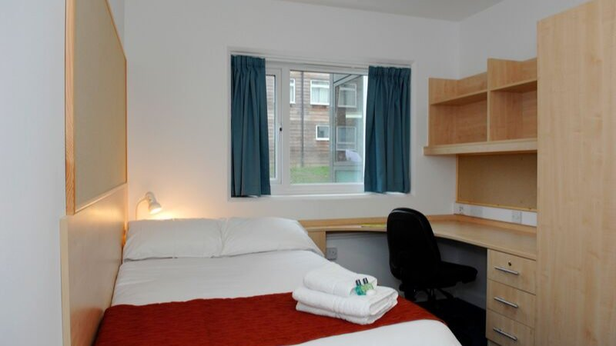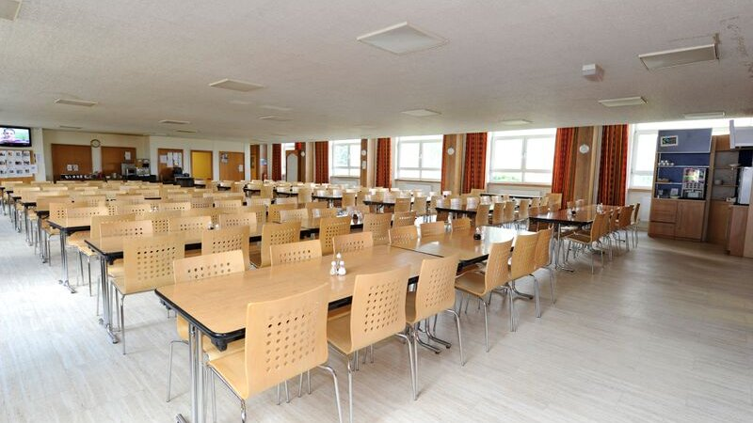

Loughborough University, Ashby Road, Loughborough, UK, from 12 to 17 age

Course intensity | 15
Accommodation | Campus
Room type | Single
Bathroom facilities | En-suite
Meals | Breakfast, Lunch and Dinner
Excursions per week | 2
Weekday excursions
Full day excursions | 2

Description

Why choose this program

Infrastructure

Sport infrastructure

Hobbies and clubs

What else included in the program price

Recommended arrival city

Лондон

Sample timetable
 | Morning | Afternoon | Evening
Day 1 | Orientation Tour | Orientation Tour | Orientation Tour
Day 2 | Social Games and Sports including: Swimming, Volleyball, Basketball, Rounders | Create it! - Play it! | Summer Disco
Day 3 | Full Day to Cambridge | Entry ticket to Kings College | Knockout
Day 4 | Full Day Excursion to York | Entry to The Viking Museum | Monopoli
Day 5 | Lesson | Academy Session (Football/Rugby/Dance) | Disco
Day 6 | Lesson | Academy Session (Football/Rugby/Dance) | PLUS Factor - Karaoke night
Day 7 | Lesson | Academy Session (Football/Rugby/Dance) | Disco
Day 8 | Optional excursion | Optional excursion | Optional excursion
Day 9 | Full Day Excursion to Cambridge | Full Day Excursion to Cambridge | Full Day Excursion to Cambridge
Day 10 | Lessons | Sports activities | Disco
Day 11 | Lessons | Sports activities | Murder Mystery
Day 12 | Lessons | Sports activities | Scavenger Hunt
Day 13 | Lessons | Sports activities | Knockout
Day 14 | Lessons | Sports activities | Plus Has Got Talent

For booking please go to www.travelclass.org

