ALPADIA Engelberg — summer school in Switzerland

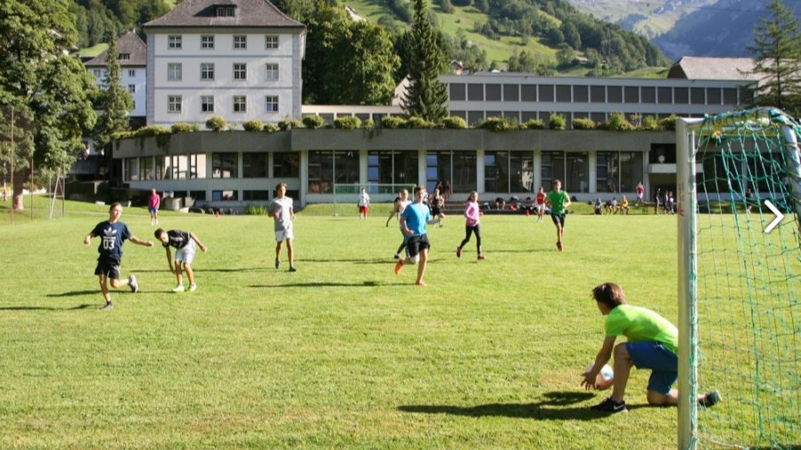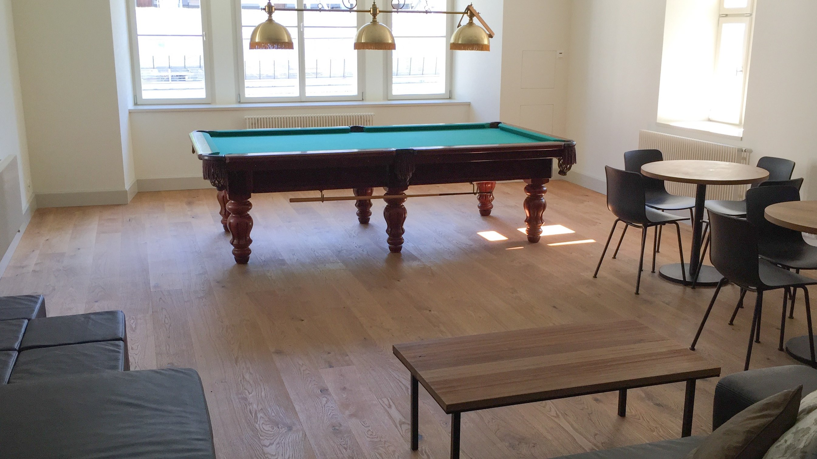

Engelberg, Switzerland, from 10 to 17 age

Course intensity | 20
Accommodation | Campus
Room type | Twin
Bathroom facilities | Shared
Meals | Breakfast, Lunch and Dinner
Excursions per week | 2
Weekday excursions | 1
Full day excursions | 1

Description

Why choose this program

Infrastructure

Sport infrastructure

Hobbies and clubs

What else included in the program price

Recommended arrival city

Цюрих

Sample timetable
 | Morning | Afternoon | Evening
Day 1 | Arrival day | Registration | Welcome party
Day 2 | Classes | Package activities | Sports tournament
Day 3 | Classes | Package activities | Movie night
Day 4 | Classes | Hiking excursion | BBQ
Day 5 | Classes | Package activities | Free evening
Day 6 | Classes | Package activities | Disco party
Day 7 | Free time | Shopping excursion to Zurich | Talent night
Day 8 | Free day
Day 9 | Classes | Trip to Lido | Disco
Day 10 | Classes | Package activities | Sport
Day 11 | Classes | Package activities | Movie
Day 12 | Classes | Trip to Lucerne | Games
Day 13 | Classes | Package activities | Disco
Day 14 | Departure

For booking please go to www.travelclass.org

