KKCL London - Harrow School

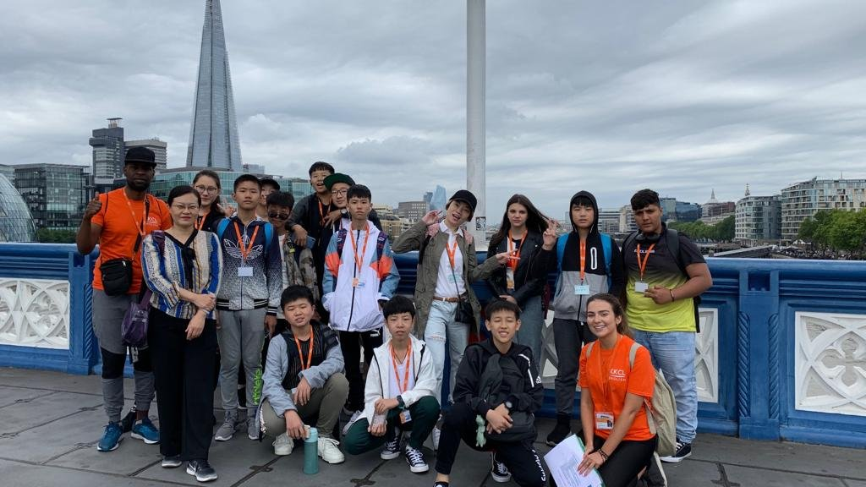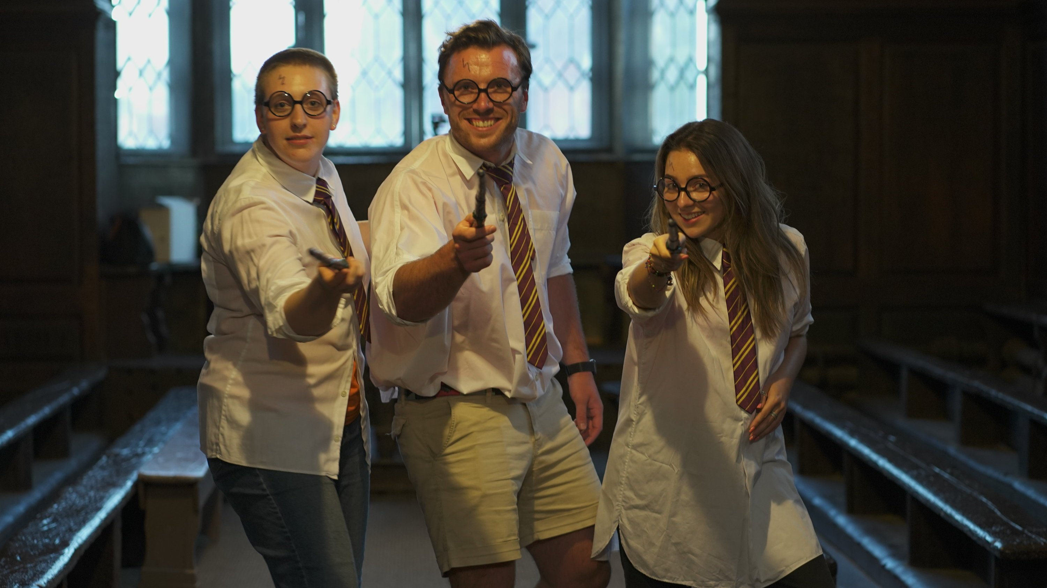

5 High St, Harrow HA1 3HP, UK, from 12 to 17 age

Course intensity | 15
Accommodation | Residence
Room type | Twin
Bathroom facilities | Shared
Meals | Breakfast, Lunch and Dinner
Excursions per week | 3
Weekday excursions | 1
Full day excursions | 2

Description

Why choose this program

Infrastructure

Sport infrastructure

Hobbies and clubs

What else included in the program price

Recommended arrival city

Лондон

Sample timetable
 | Morning | Afternoon | Evening
Day 1 | Arrival | Harrow School Welcome Tour & Induction (New Students Only) | Downtime
Day 2 | Level Test and Induction & Go Create! English | Go Create! English | Sport >Harrow Fives
Day 3 | City Visit > Day-trip to Cambridge/Oxford/Brighton/Bath | All Day | Ice Breaking & British Culture Night
Day 4 | Go Create! English | Sport & Games >Swimming/Tennis/Touch Rugby/Volleyball | KKCL Disco
Day 5 | Full Day Excursion > National Gallery > Trafalgar Square | > Heart of London Walking Tour | Film Night
Day 6 | Full Day Excursion >British Museum* >Oxford Street | >Parks and Palaces >Piccadilly Circus | Quiz Night
Day 7 | Go Create! English | Go Create! English | BBQ Party
Day 8 | Sport > Rock Climbing/Assault Course for Adventure /Basketball | Local Visit > Explore Harrow & Harrow Town Centre OR >Swimming | Downtime
Day 9 | Go Create! English | Go Create! English | Outdoor Football & Tennis
Day 10 | City Visit > Day-trip to Cambridge/Oxford/Brighton/Bath | All Day | English Master Class at 4th Form Room
Day 11 | Go Create! English | Sport & Games >Swimming/Tennis/Touch Rugby/Volleyball | KKCL Disco
Day 12 | Full Day Excursion >Natural History Museum >Kensington Palace | >Primrose Hill >Abbey Road | Film Night
Day 13 | Full Day Excursion >Boat trip to Greenwich* | >National Maritime Museum | Poetry Night
Day 14 | Go Create! English | Go Create! English | Graduation Ceremony & Formal Supper

For booking please go to www.travelclass.org

