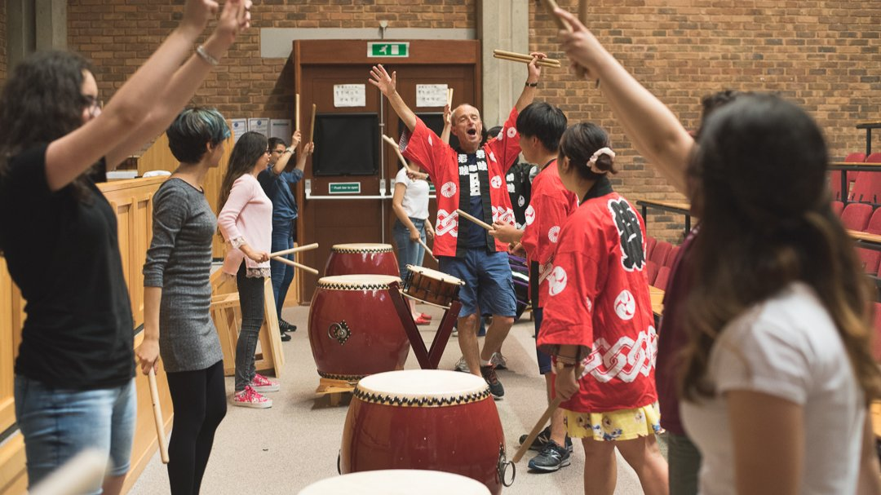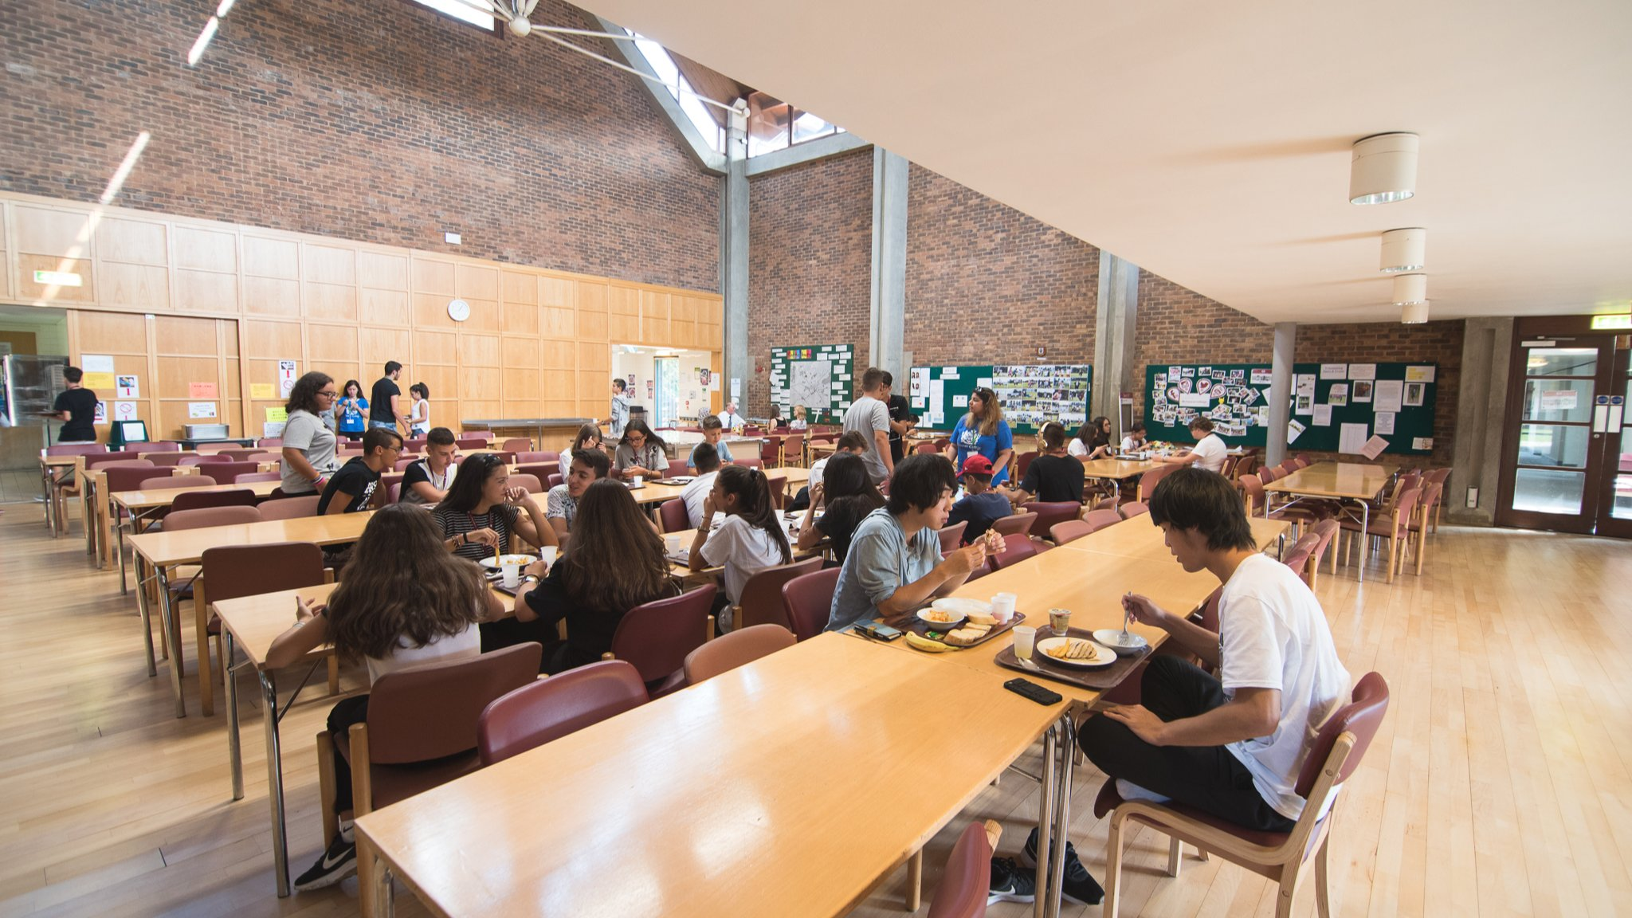

Chaucer College — English language school in the UK
Canterbury CT2 7LJ, UK, from 10 to 17 age

Course intensity | 15
Accommodation | Campus
Room type | Twin
Bathroom facilities | Shared
Meals | Breakfast, Lunch and Dinner
Excursions per week | 2
Weekday excursions | 1
Full day excursions | 1

Description

Why choose this program

Infrastructure

Sport infrastructure

Hobbies and clubs

What else included in the program price

Recommended arrival city

Лондон

Sample timetable
 | Morning | Afternoon | Evening
Day 1 | Arrival | Local Tour | On-site activities
Day 2 | Lesson | City tour | Disco
Day 3 | Lesson | Free time | On-site activities
Day 4 | Lesson | Free time | Activity
Day 5 | Lesson | Half day excursion | Activity
Day 6 | Excursion | Excursion | On-site activities
Day 7 | Lesson | On-site activities | On-site activities

Price: €1,171.05

Dates: 2020-05-03 - 2020-05-10

Group leader: Giunai Dzhafarova, +7 (977) 584 99 95, gunaye4ka@mail.ru

