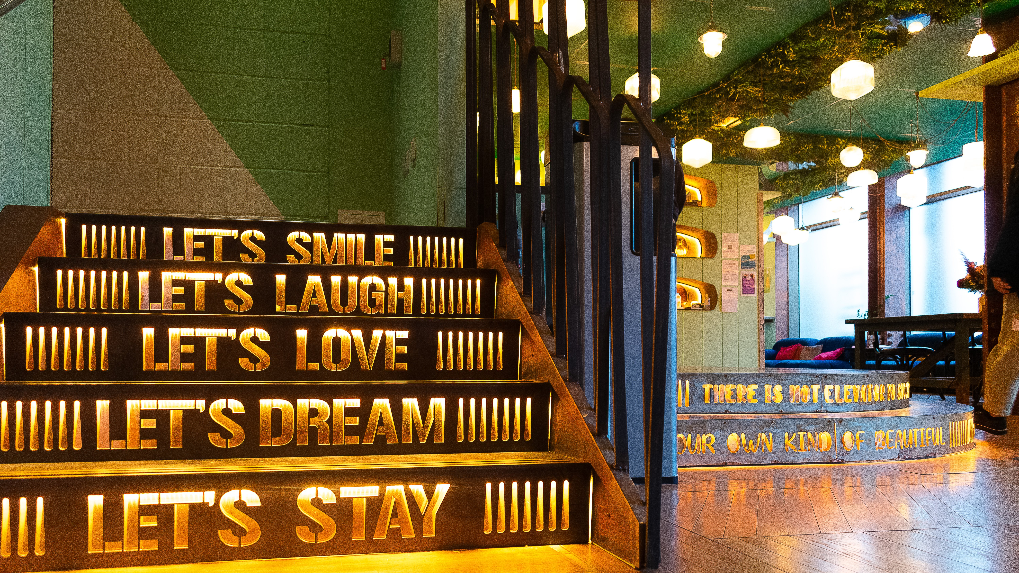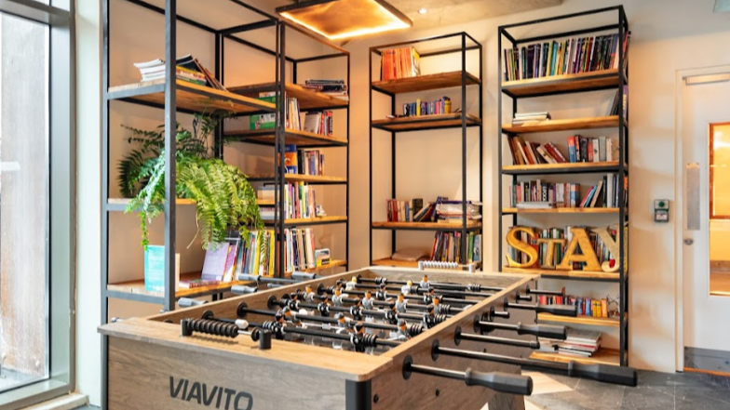

SCL International College North Acton — London language school, UK
200 Western Avenue, London, W3 6FW, from 12 to 17 age

Course intensity | 15
Accommodation | Campus
Room type | Twin
Bathroom facilities | En-suite
Meals | Breakfast + Dinner
Excursions per week | 0
Weekday excursions
Full day excursions

Description

Why choose this program

Infrastructure

Sport infrastructure

Hobbies and clubs

What else included in the program price

Recommended arrival city

Лондон

Sample timetable
 | Morning | Afternoon | Evening
Day 1
Day 2
Day 3
Day 4
Day 5
Day 6
Day 7

Price: €1,023.33

Dates: 2019-10-05 - 2019-10-12

Group leader: Skvortsova Irina, +7 (916) 171 22 46, Irinastarling@rambler.ru

