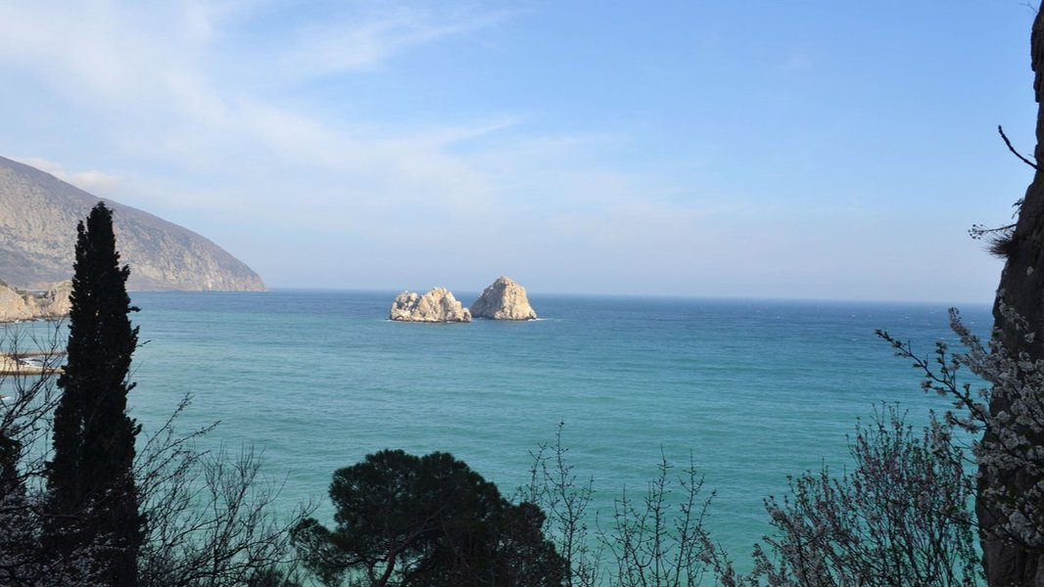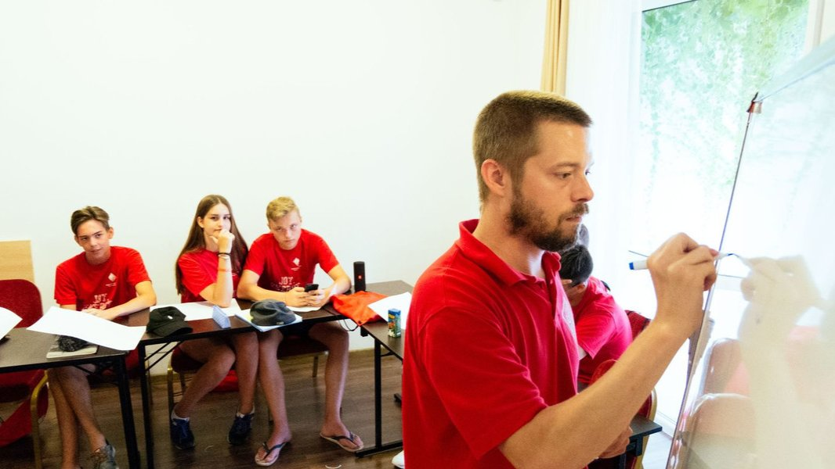

Jey Academy Crimea — summer school in Russia
набережная имени Пушкина, 1, Гурзуф, from 9 to 17 age

Course intensity | 15
Accommodation | Campus
Room type | Triple
Bathroom facilities | En-suite
Meals | Breakfast, Lunch and Dinner
Excursions per week | 0
Weekday excursions | 0
Full day excursions | 0

Description

Why choose this program

Infrastructure

Sport infrastructure

Hobbies and clubs

What else included in the program price

Recommended arrival city

Симф

Sample timetable
 | Morning | Afternoon | Evening
Day 1 | Lessons | Sports & Leisure Activities | Games
Day 2 | Lessons | Excursion | Quest
Day 3 | Lessons | Beach | Games Night
Day 4 | Lessons | Sports & Leisure Activities | Disco
Day 5 | Lessons | Beach | Contests
Day 6 | Sports contest | Tour | Disco
Day 7 | Sport | Excursion | Quest
Day 8
Day 9
Day 10
Day 11
Day 12
Day 13
Day 14

Price: €863.25

Dates: 2021-07-13 - 2021-07-26

Group leader: AKHMETGALEEVA Olga Vladimirovna , 79778026654, muska28@mail.ru

