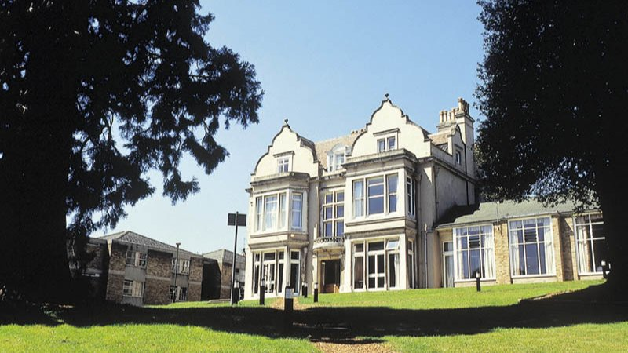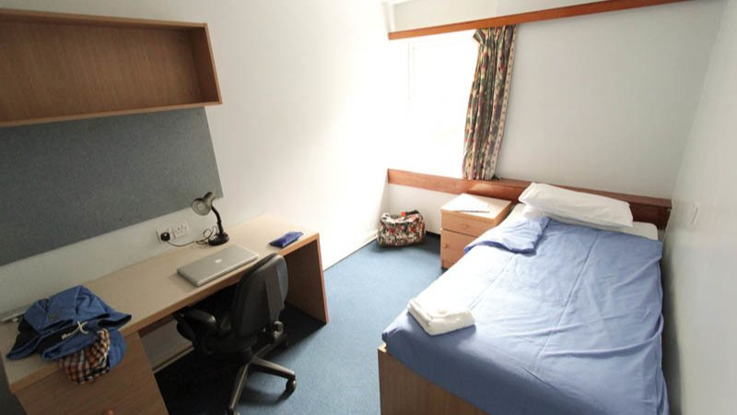

Embassy Summer Kingswood Royal Holloway — summer school in the UK
Kingswood Hall, Cooper's Hill Lane, Englefield Green, Egham, UK, from 10 to 17 age

Course intensity | 15
Accommodation | Campus
Room type | Single
Bathroom facilities | Shared
Meals | Breakfast, Lunch and Dinner
Excursions per week | 3
Weekday excursions | 2
Full day excursions | 1

Description

Why choose this program

Infrastructure

Sport infrastructure

Hobbies and clubs

What else included in the program price

Recommended arrival city

Лондон

Sample timetable
 | Morning | Afternoon | Evening
Day 1 | Arrivals/Onsite Activities or optional trip to Portsmouth Historic Dockyards | Field Sports | Get to Know You Games
Day 2 | Testing/Induction or Lessons | Egham Town Walk | Capture the Flag
Day 3 | Lessons | Lessons | Kahoot Quiz Night
Day 4 | Full Day Trip to London with Westminster Walking Tour and visit to the National Gallery | Full Day Trip to London with Westminster Walking Tour and visit to the National Gallery | Hit n’ Run Cricket
Day 5 | Lessons | Visit to Kew Gardens | Big Game Bingo
Day 6 | Lessons | Mini Olympics Team Events | Cross Dress Disco
Day 7 | Full Day Trip to Oxford with Walking Tour and College Entrance | Full Day Trip to Oxford with Walking Tour and College Entrance | Film Night

Price: €1,619.92

Dates: 2019-07-14 - 2019-07-28

Group leader: Travel Class, 74952042055, teachertest@travelclass.org

