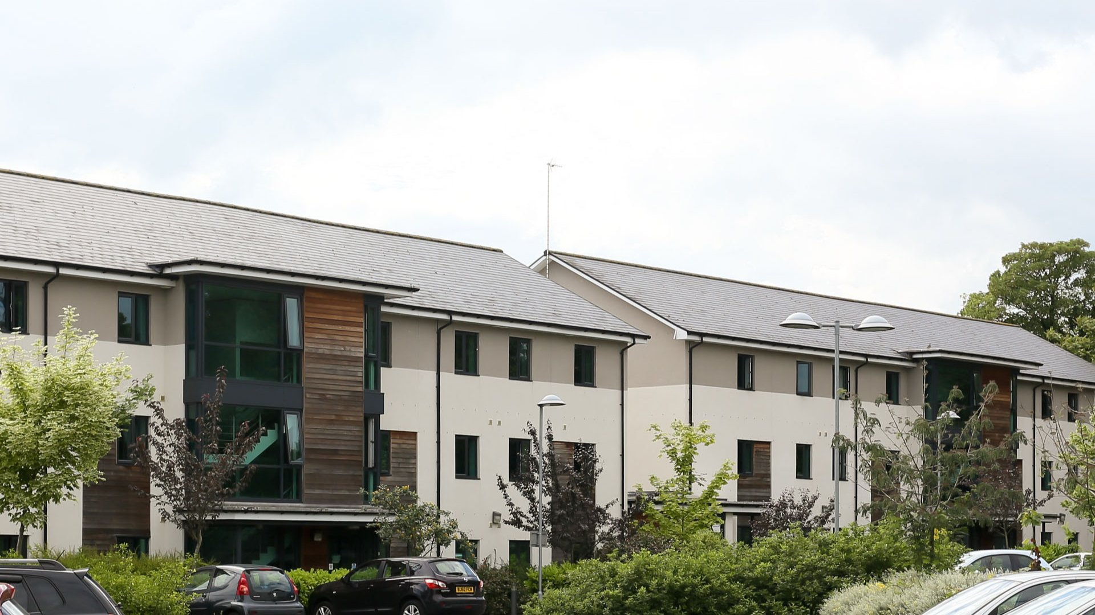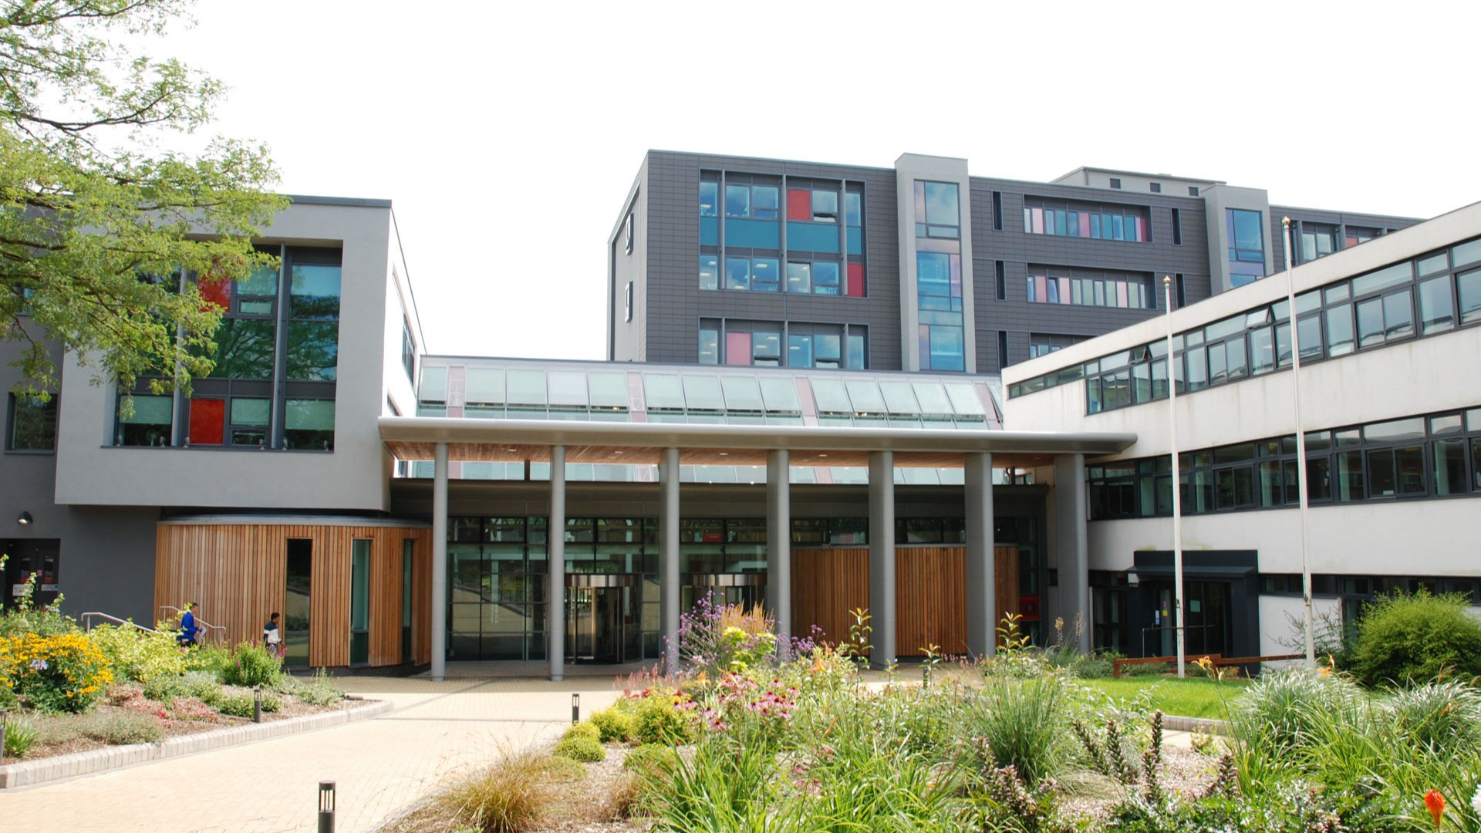

Twin Royal Leamington Spa — summer school in the UK
Warwick New Road, Leamington Spa, UK, from 10 to 17 age

Course intensity | 15
Accommodation | Campus
Room type | Single
Bathroom facilities | En-suite
Meals | Breakfast, Lunch and Dinner
Excursions per week | 3
Weekday excursions | 2
Full day excursions | 1

Description

Why choose this program

Infrastructure

Sport infrastructure

Hobbies and clubs

What else included in the program price

Recommended arrival city

Лондон

Sample timetable
 | Morning | Afternoon | Evening
Day 1 | Meet & Greet / Orientation Tour | Social Games | Welcome evening
Day 2 | Testing/lessons | Walking tour in Leamington Spa | Building competition
Day 3 | English lessons | Half day excursion to Warwick Castle (with entrance) | Quiz Night
Day 4 | English lessons | Sports tournament | Staff vs students
Day 5 | Full day excursion to Oxford | Walking tour in Oxford | Film Night
Day 6 | English lessons | Arts & Crafts workshop: jewellery / Conversation Club | Photo Competition
Day 7 | English lessons | Badminton/Tennis/Football/Drama Club/Conversation Club | Karaoke Night
Day 8 | Social games | Badminton/Tennis/Football/Drama Club/ Art & Crafts: bracelets / Conversation Club | Scavenger Hunt
Day 9 | English lessons | Tennis/Football/Leamington Spa Art Gallery & Museum | Mystery Night
Day 10 | English lessons | Half day excursion to Stratford-upon-Avon with entrance to Shakespeare's Birthplace | Paper Fashion Show
Day 11 | English lessons | Twin's Got Talent Preparation | Twin’s Got Talent
Day 12 | Full day excursion to London with Thames River Cruise | Full day excursion to London with Thames River Cruise | Full day excursion to London with Thames River Cruise
Day 13 | English lessons | Arts & Crafts workshop: memories / Conversational Club / Olympic games | Music Quiz
Day 14 | English lessons | Leamington Spa Treasure Hunt | Departure Ceremony & Farewell disco

Price: €1,983.86

Dates: 2020-07-01 - 2020-07-15

Group leader: Kazakova Irina, +8 (952) 021 57 15, kazirinka05@mail.ru

