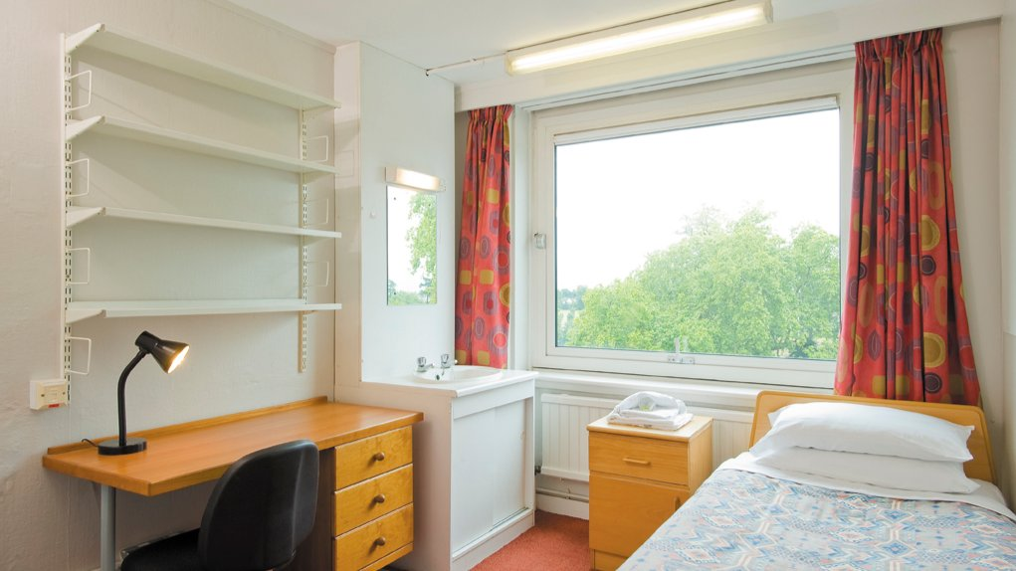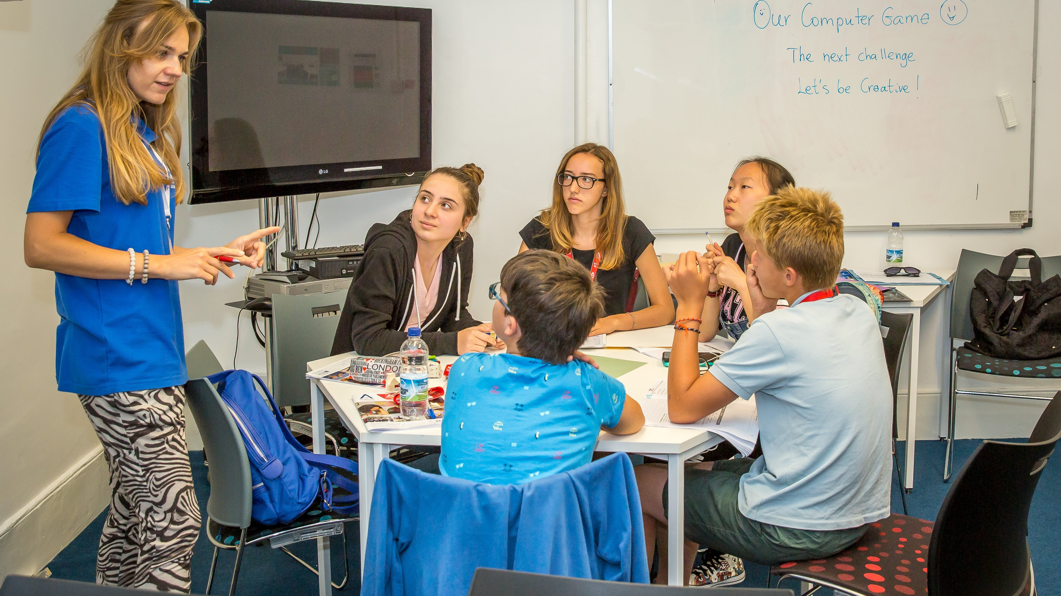

Ardmore University of Reading — summer school in the UK
Reading University, Reading, UK, from 12 to 17 age

Course intensity | 15
Accommodation | Campus
Room type | Single
Bathroom facilities | Shared
Meals | Breakfast, Lunch and Dinner
Excursions per week | 2
Weekday excursions | 1
Full day excursions | 1

Description

Why choose this program

Infrastructure

Sport infrastructure

Hobbies and clubs

What else included in the program price

Recommended arrival city

Лондон

Sample timetable
 | Morning | Afternoon | Evening
Day 1 | Arrival | Arrival | Arrival
Day 2 | Lessons | Sports & Leisure Activities | Welcome Icebreaker Games
Day 3 | Lessons | Sports & Leisure Activities | Blind Date
Day 4 | Lessons | Half Day Excursion to Windsor Castle | Talent Show
Day 5 | Lessons | Sports & Leisure Activities | Casino Night
Day 6 | Lessons | Sports and Leisure Activities | Disco
Day 7 | Full Day Excursion to London, Thames River Cruise and Westminster Walking Tour Late return meal voucher provided | Full Day Excursion to London, Thames River Cruise and Westminster Walking Tour Late return meal voucher provided | Sports Tournament
Day 8 | Sports and Leisure Activities on Campus / Optional Extra Excursions | Sports and Leisure Activities on Campus / Optional Extra Excursions | Movie Night
Day 9 | Sports & Leisure Activities | Lessons | Capture the Flag
Day 10 | Sports & Leisure Activities | Lessons | Find Dr Ardmore
Day 11 | Half Day Excursion to Reading Town and Museum | Lessons | Karaoke
Day 12 | Sports & Leisure Activities | Lessons | Rounders
Day 13 | Sports & Leisure Activities | Lessons | Disco
Day 14 | Full day in Oxford | Full day in Oxford | Full day in Oxford

Price: €1,864.35

Dates: 2020-06-28 - 2020-07-12

Group leader: Larisa Gareeva, +7 (917) 460 82 01, larisagareeva@mail.ru

