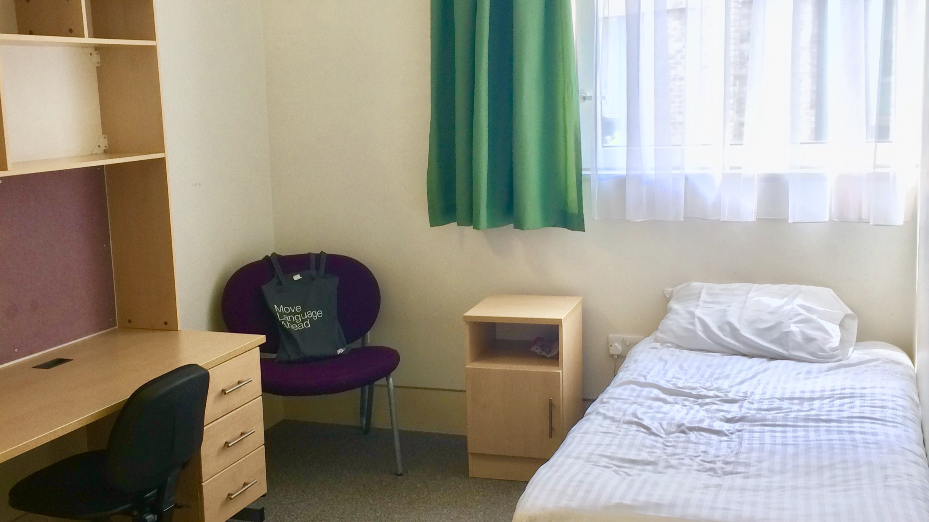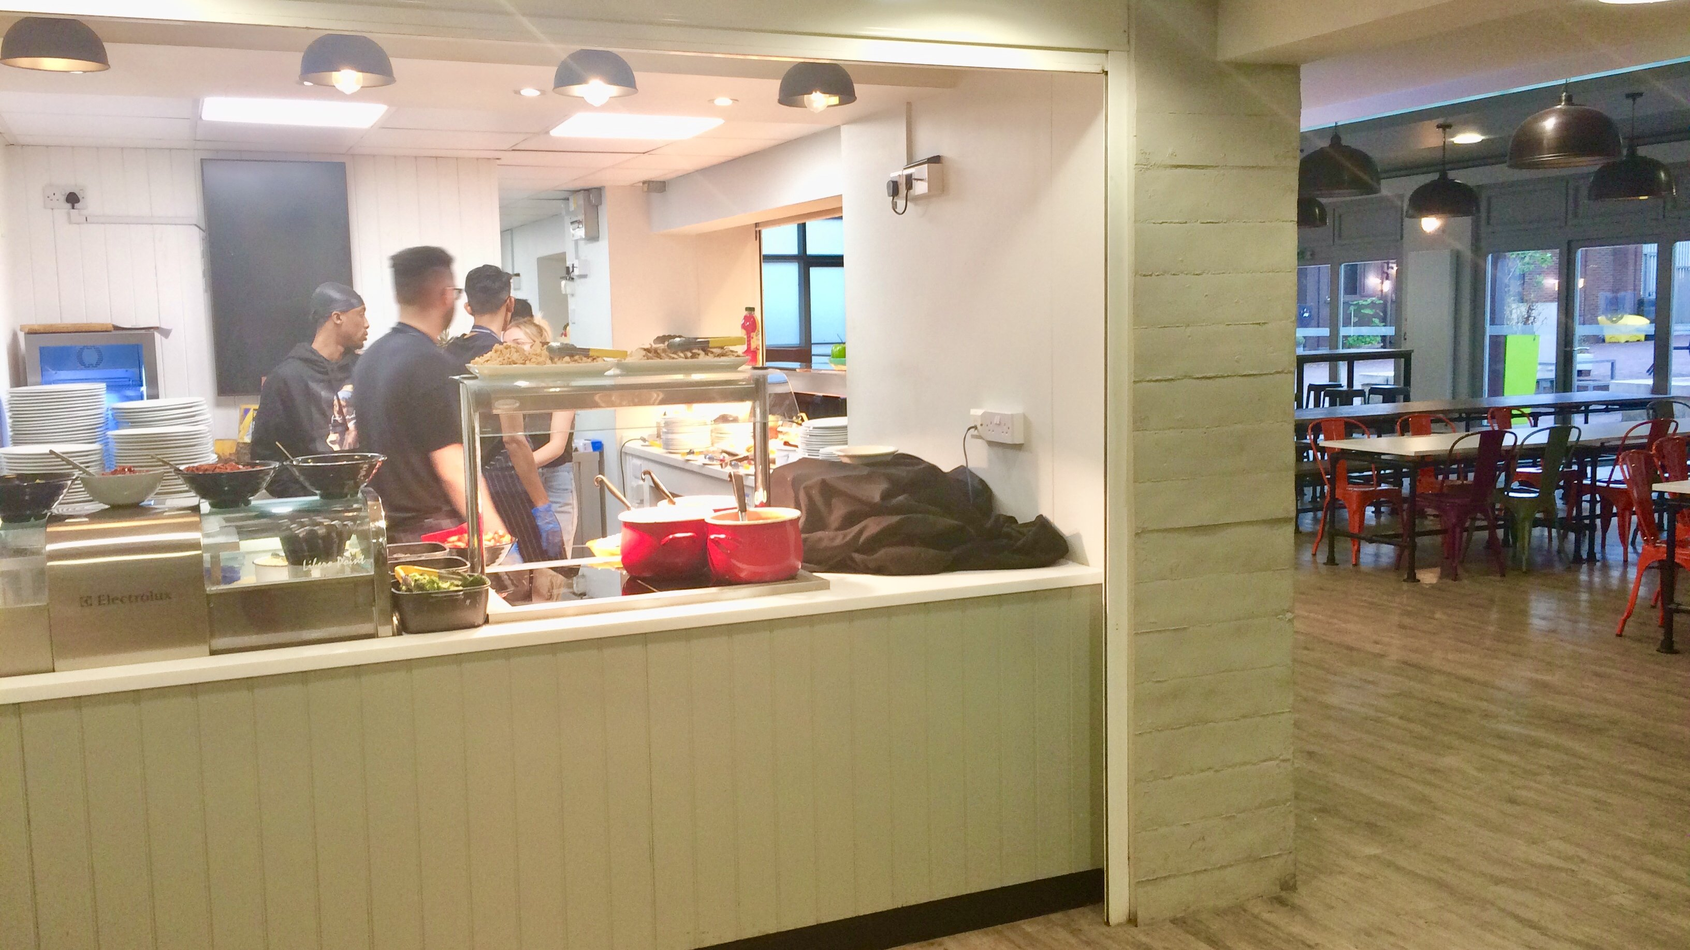

MLA London Roehampton University — summer school in the UK
London SW15 5PU, UK, from 11 to 18 age

Course intensity | 15
Accommodation | Campus
Room type | Single
Bathroom facilities | En-suite
Meals | Breakfast, Lunch and Dinner
Excursions per week | 6
Weekday excursions | 4
Full day excursions | 2

Description

Why choose this program

Infrastructure

Sport infrastructure

Hobbies and clubs

What else included in the program price

Recommended arrival city

Лондон

Sample timetable
 | Morning | Afternoon | Evening
Day 1 | Arrival | Orientation | Welcome party
Day 2 | Lessons | Walking Tour | Movie night
Day 3 | Lessons | Winchester cathedral | Disco
Day 4 | Lessons | Multi Sport | Quiz night
Day 5 | Lessons | Shopping at Oracle | Karaoke
Day 6 | Lessons | Multi Sport | Treasure Hunt
Day 7 | London walking tour | Cruise on Thames | Dinner at Hard Rock Caffe

Price: €2,073.77

Dates: 2020-07-23 - 2020-08-05

Group leader: Pakuleva Margarita Borisovna, +7 (906) 748 93 52, Pakuleva-m@yandex.ru

