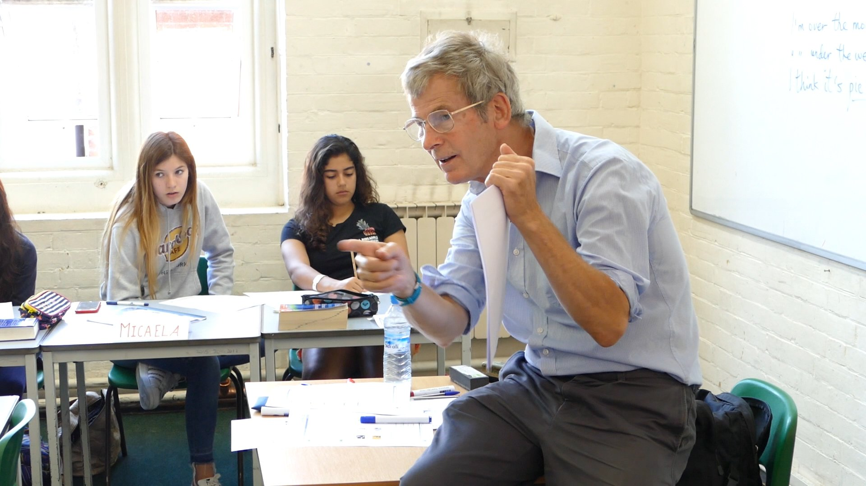

UK College of English Godolphin School — summer school in the UK
Godolphin School, Milford Hill, Salisbury SP1 2RA, UK, from 13 to 17 age

Course intensity | 20
Accommodation | Residence
Room type | Twin
Bathroom facilities | Shared
Meals | Breakfast, Lunch and Dinner
Excursions per week | 3
Weekday excursions | 1
Full day excursions | 2

Description

Why choose this program

Infrastructure

Sport infrastructure

Hobbies and clubs

What else included in the program price

Recommended arrival city

Лондон

Sample timetable
 | Morning | Afternoon | Evening
Day 1 | Placement testing and induction | Salisbury Orientation | Quiz Night
Day 2 | Classes | Football, Volleyball, Tennis or Arts and Craft | Mini Olympics
Day 3 | Excursion Class | Excursion to Winchester | Movie Night in the Theatre
Day 4 | Classes | Swimming Club or Zumba Class | Disco
Day 5 | Classes | Afternoon Town Trail | Murder Mystery Evening
Day 6 | Excursion to London | Excursion to London | Casino Night
Day 7 | Excursion to Oxford | Excursion to Oxford | Mini-Olympics

Price: €1,591.58

Dates: 2019-07-07 - 2019-07-20

Group leader: Alla Kleshcheva, +7 (916) 218 86 90, Kleshchova@rambler.ru

