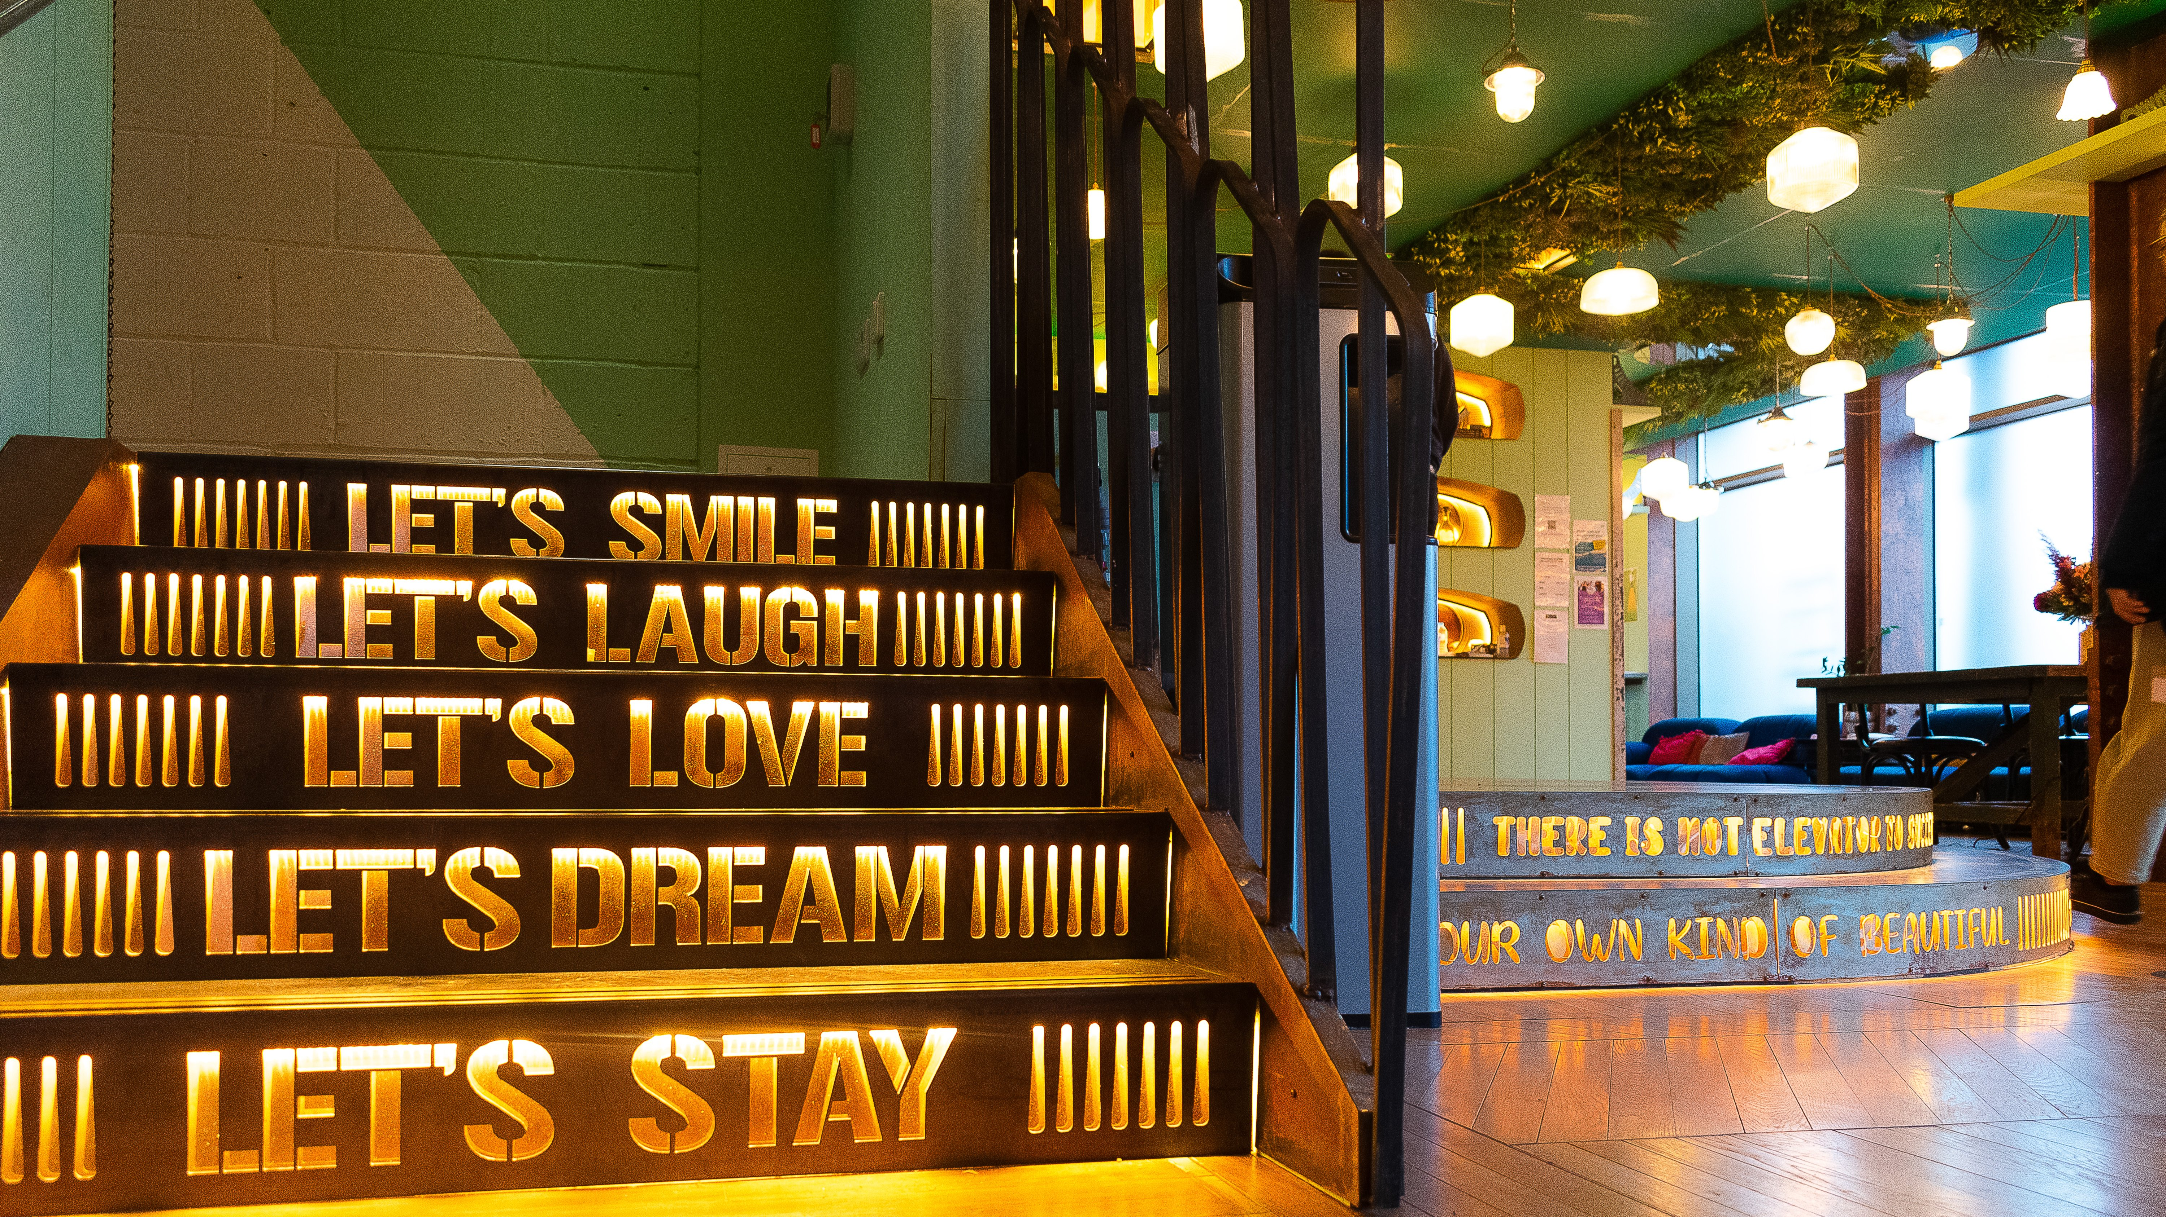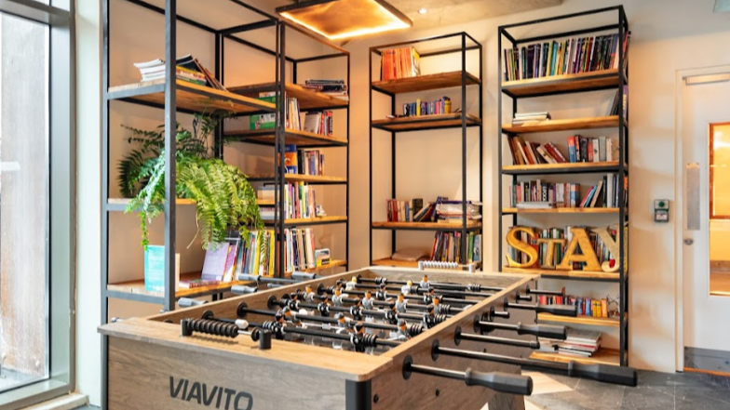

SCL International College North Acton — London language school, UK
200 Western Avenue, London, W3 6FW, from 12 to 17 age

Course intensity | 15
Accommodation | Residence
Room type | Twin
Bathroom facilities | En-suite
Meals | Breakfast, Lunch and Dinner
Excursions per week | 3
Weekday excursions | 3
Full day excursions | 0

Description

Why choose this program

Infrastructure

Sport infrastructure

Hobbies and clubs

What else included in the program price

Recommended arrival city

Лондон

Sample timetable
 | Morning | Afternoon | Evening
Day 1
Day 2
Day 3
Day 4
Day 5
Day 6
Day 7

Price: €1,043.85

Dates: 2020-06-28 - 2020-07-04

Group leader: Dudesh Olga, +7 (977) 986 28 00, olga.doudesh@gmail.com

