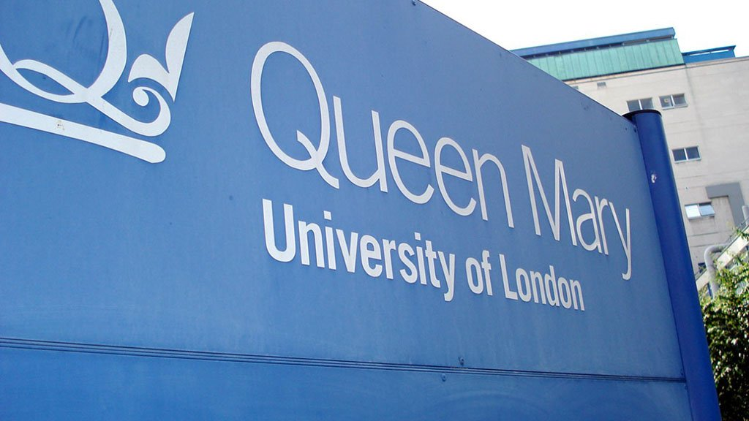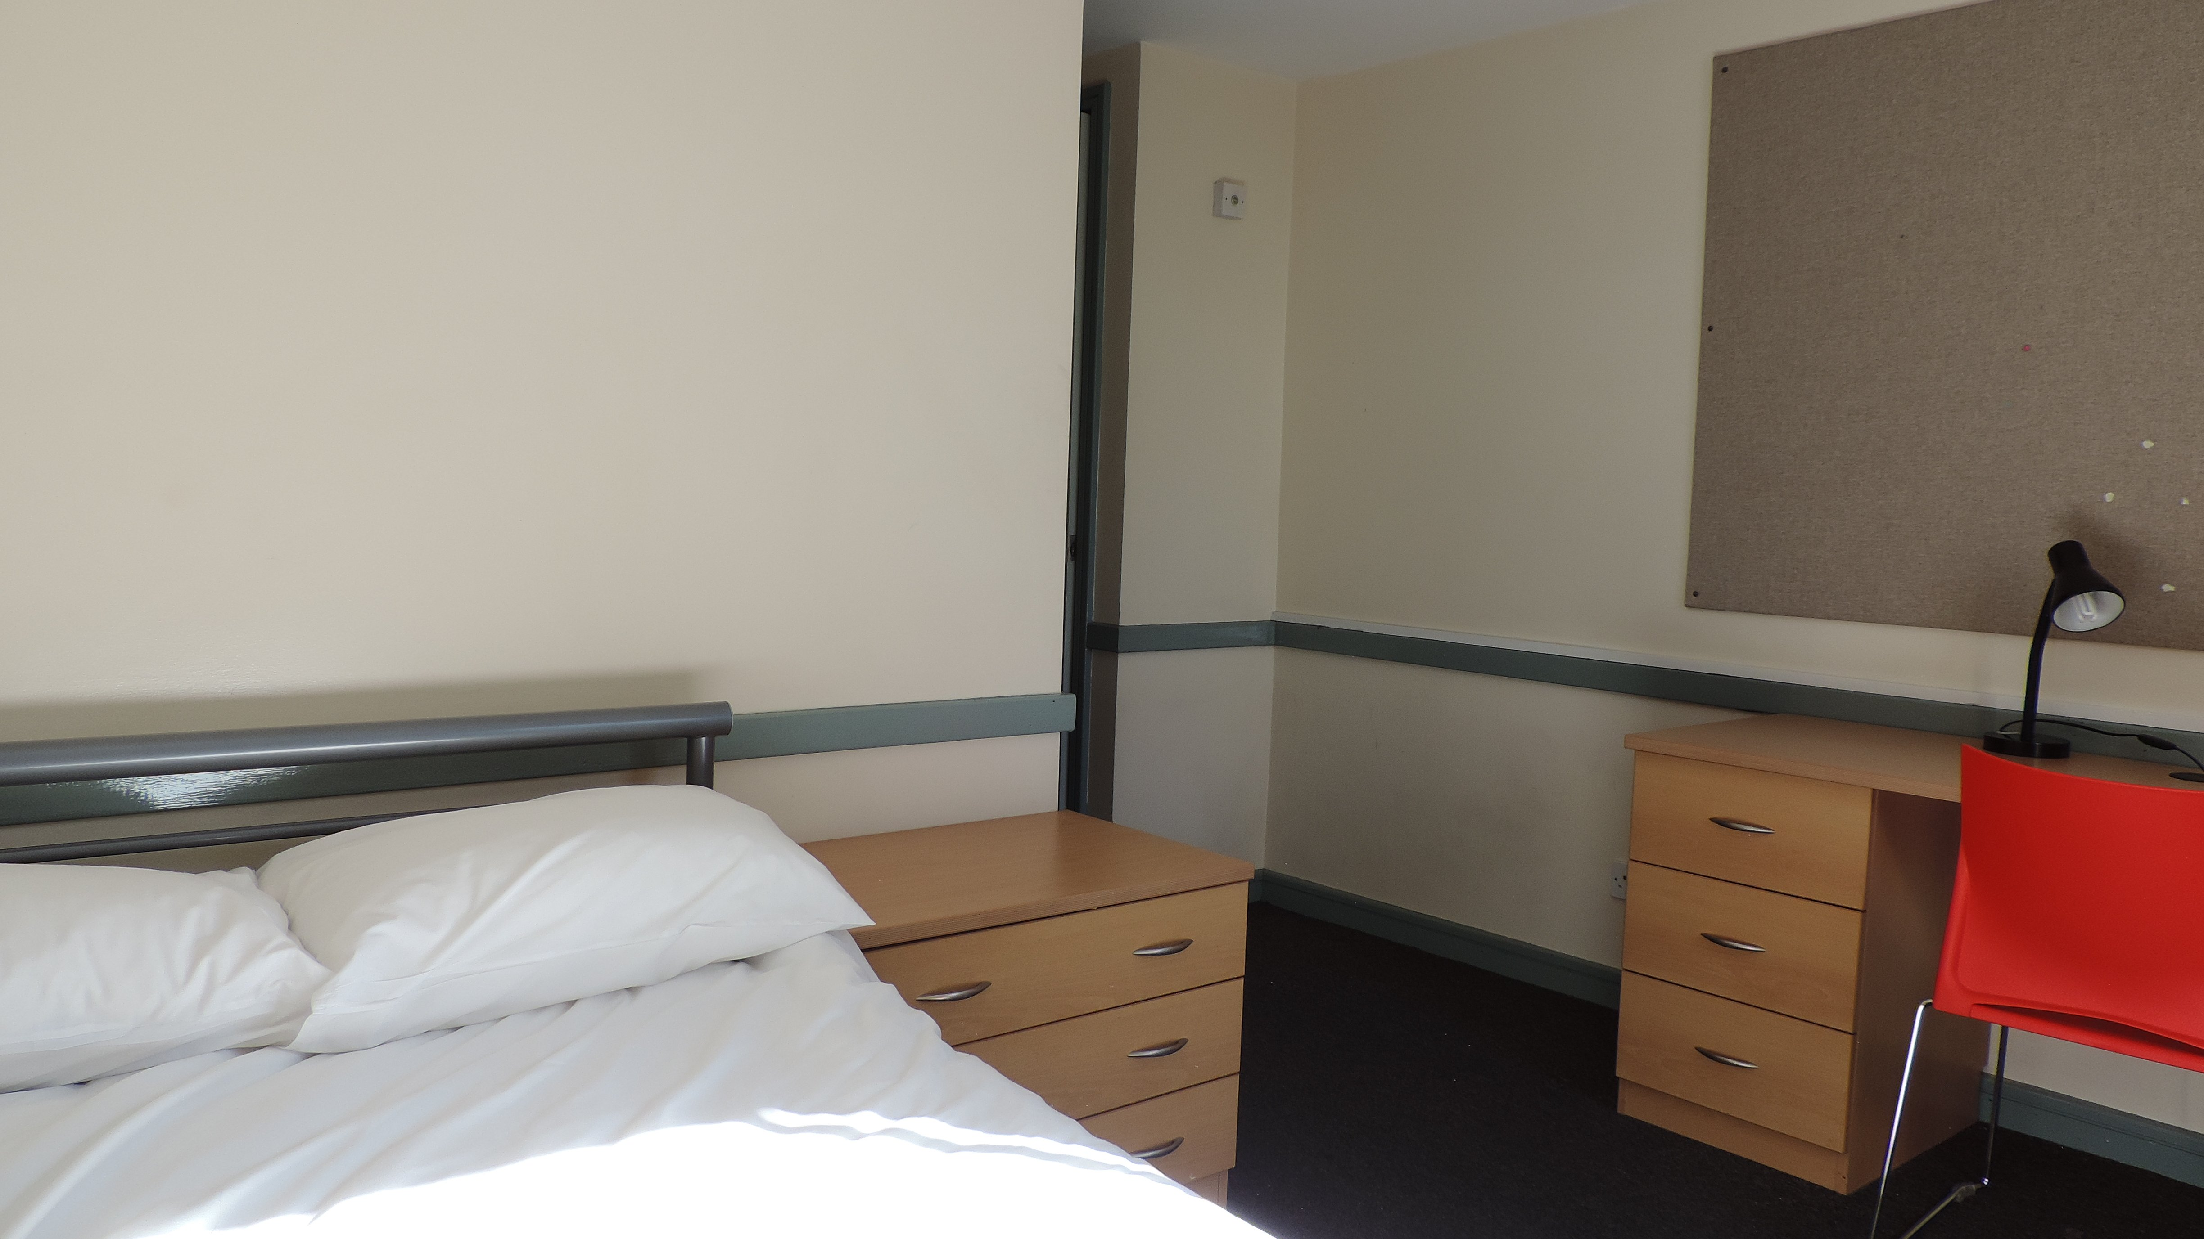

MLA London Mile End Queen Mary University of London — summer school in the UK
Mile End Rd, London E1 4NS, UK, from 12 to 17 age

Course intensity | 15
Accommodation | Residence
Room type | Single
Bathroom facilities | En-suite
Meals | Breakfast, Lunch and Dinner
Excursions per week | 7
Weekday excursions | 5
Full day excursions | 2

Description

Why choose this program

Infrastructure

Sport infrastructure

Hobbies and clubs

What else included in the program price

Recommended arrival city

Лондон

Sample timetable
 | Morning | Afternoon | Evening
Day 1 | Arrival | Orientation | Welcome party
Day 2 | Lessons | London Walking tour | Disco
Day 3 | Lessons | Multi sports | Quiz Night
Day 4 | Lessons | Oxford street shopping | The Amazing MLA Race
Day 5 | Lessons | Multi sports | Karaoke
Day 6 | Lessons | Free time | Hawaiian Disco
Day 7 | Full day trip to Brighton | Canterbury Brighton | Fashion night

Price: €2,659.66

Dates: 2020-07-02 - 2020-07-15

Group leader: AKHMETGALEEVA Olga Vladimirovna , 79778026654, muska28@mail.ru

