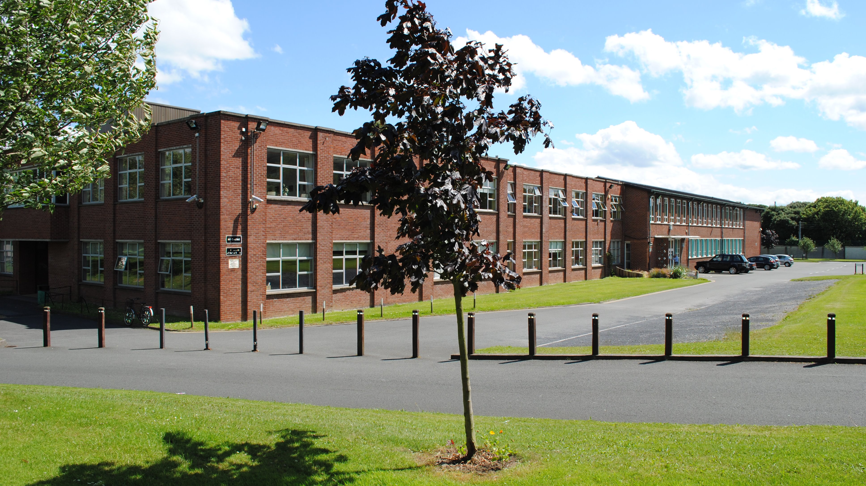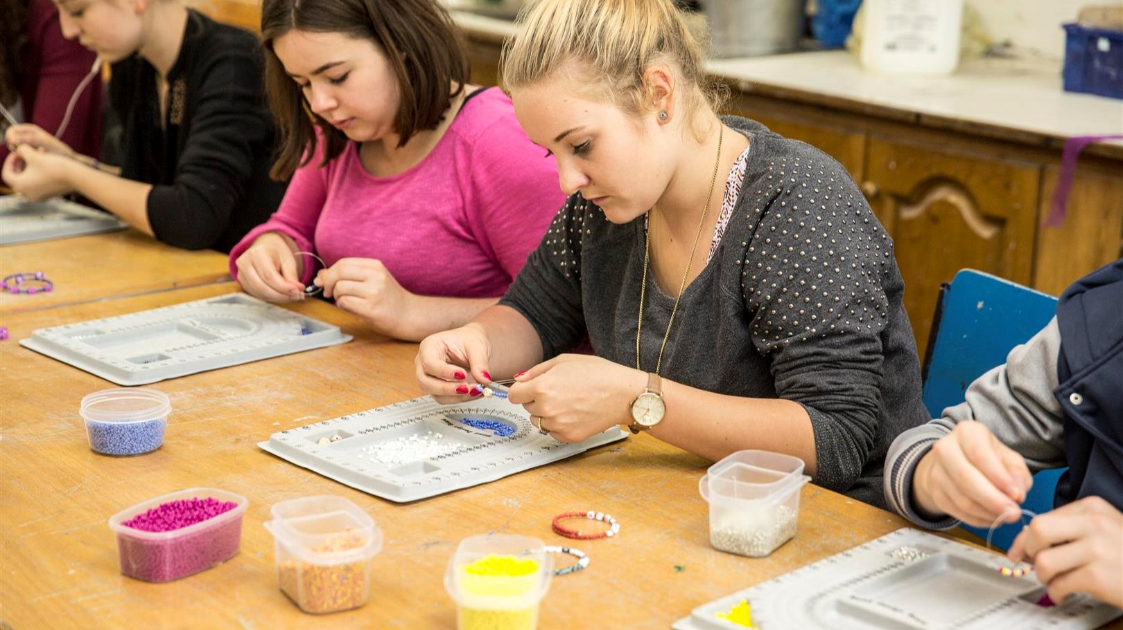

CES Dublin — language school in Ireland
31 Dame Street, Dublin 2, Ireland, from to age

Course intensity | 20
Accommodation | Host family
Room type | Twin
Bathroom facilities | Shared
Meals | Breakfast, Lunch and Dinner
Excursions per week | 3
Weekday excursions | 2
Full day excursions | 1

Description

Why choose this program

Infrastructure

Sport infrastructure

Hobbies and clubs

What else included in the program price

Recommended arrival city

Дублин

Sample timetable
 | Morning | Afternoon | Evening
Day 1 | Level placement and induction. Welcome talk by CES Principal | Orientation Tour of Dublin with CES Teache | Homestay
Day 2 | Lessons | Recreation Afternoon | Visit to Howth fishing village
Day 3 | Lessons | Open Bus Tour of Dublin with CES Teacher | Irish Music Night
Day 4 | Lessons | Recreation Afternoon | Disco
Day 5 | Lessons | Shopping in city centre! | Homestay
Day 6 | Powersourt Gardens and Glendalough Full Day Excursion | Powersourt Gardens and Glendalough Full Day Excursion | Powersourt Gardens and Glendalough Full Day Excursion
Day 7 | Free time with family/group leader | Free time with family/group leader | Free time with family/group leader

Price: €1,147.50

Dates: 2010-02-20 - 2020-02-20

Group leader: Yanal jatkar , +7 (988) 084 51 95, Jatkaryanal@Gmail.com

