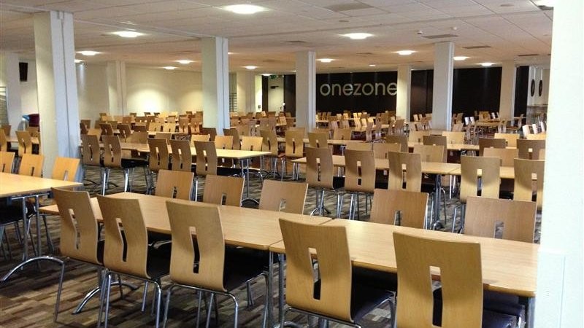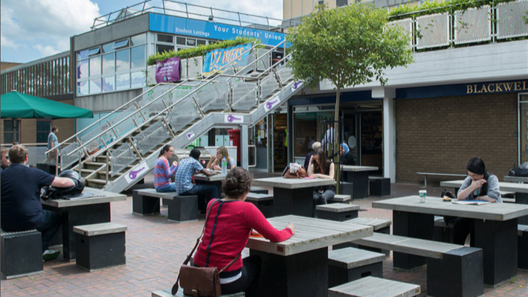

MLA University of West England — summer school in the UK
Stoke Gifford, Bristol BS16 1QY, UK, from 11 to 17 age

Course intensity | 15
Accommodation | Campus
Room type | Single
Bathroom facilities | En-suite
Meals | Breakfast, Lunch and Dinner
Excursions per week | 4
Weekday excursions | 3
Full day excursions | 1

Description

Why choose this program

Infrastructure

Sport infrastructure

Hobbies and clubs

What else included in the program price

Recommended arrival city

Лондон

Sample timetable
 | Morning | Afternoon | Evening
Day 1 | Arrival | Orientation Learning MLA Summer Song | Welcome party
Day 2 | Lessons | Half Day Bristol Walking Tour Banksy Street Art Tour | Karaoke
Day 3 | Lessons | Multi sports | Fashion Night and Chit Chat Club
Day 4 | Lessons | Half Day Bristol Clifton Suspension Bridge, Discovering Bristol | Hawaiian Disco Party
Day 5 | Lessons | Multi sports | Kahoot Night
Day 6 | Lessons | Half Day Bath Walking Tour | Selfie Scavenger Hunt
Day 7 | Full Day Stratford Upon Avon Walking Tour | Full Day Shakespeare’s Birthplace* | British Disco

Price: €2,449.86

Dates: 2020-07-02 - 2020-07-15

Group leader: Leonteva Anna Anatolyevna, +7 (916) 902 08 27, leonteva1284@yandex.ru

