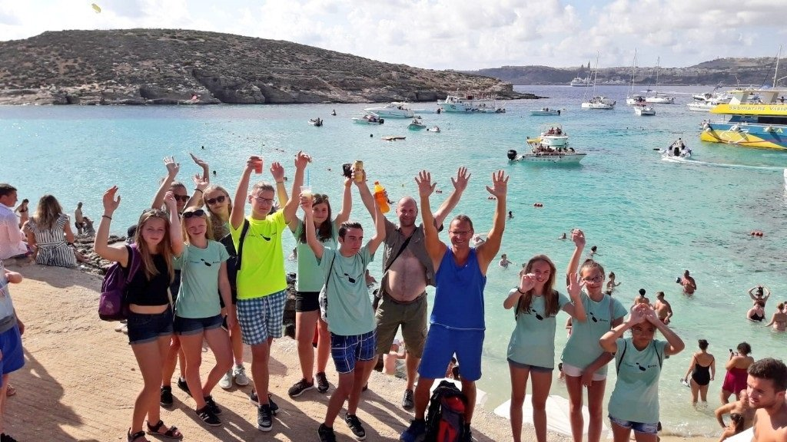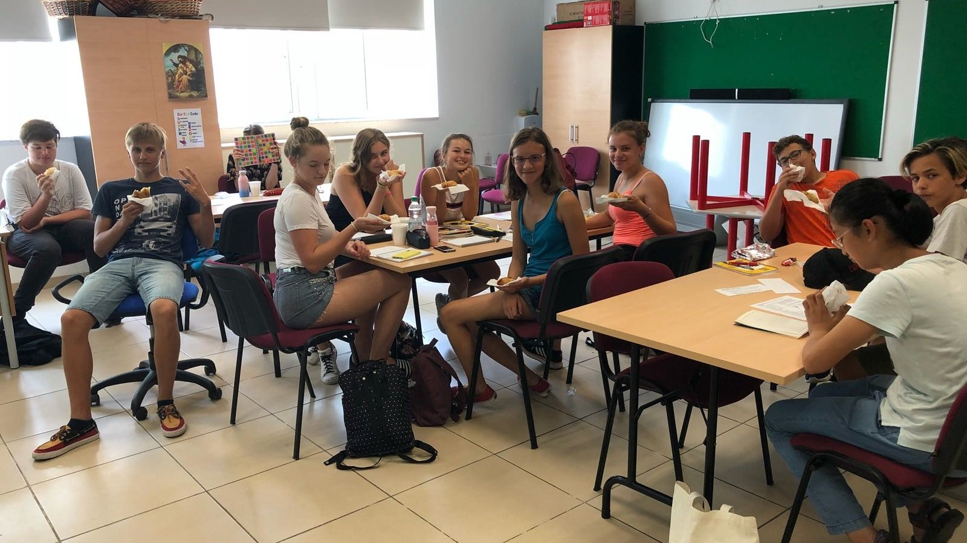

Gateway School of English — language school in Malta
San Gwann Primary School (St Clare College), Myrtle Avenue, San Gwann, from 12 to 17 age

Course intensity | 15
Accommodation | Hotel
Room type | Multi-bedded
Bathroom facilities | Shared
Meals | Breakfast, Lunch and Dinner
Excursions per week | 10
Weekday excursions | 8
Full day excursions | 2

Description

Why choose this program

Infrastructure

Sport infrastructure

Hobbies and clubs

What else included in the program price

Recommended arrival city

Luqa

Sample timetable
 | Morning | Afternoon | Evening
Day 1 | Arrival Day - Check in - Orientation walk around St Julian’s for new students | Arrival Day - Check in - Orientation walk around St Julian’s for new students | Arrival Day - Check in - Orientation walk around St Julian’s for new students
Day 2 | Lessons | Splash & Fun Waterpark | Treasure Hunt at Valletta by night
Day 3 | Lessons | Swimming at Mellieha Bay | Free Evening (Students can go out with the GSE Group Leader)
Day 4 | Lessons | Splash & Fun Waterpark | FELTOM Teen International Disco
Day 5 | Lessons | Beach Trip | Free evening
Day 6 | Lessons | Beach Trip | Bowling at Eden Super-bowl
Day 7 | Full Day at the Blue Lagoon | Full Day at the Blue Lagoon | Free Evening
Day 8 | Full Day at Golden Bay | Full Day at Golden Bay | Free time
Day 9 | Lessons | Splash & Fun Waterpark | Treasure Hunt
Day 10 | Lessons | Free afternoon | Bowling
Day 11 | Lessons | Swimming at Paradise Bay | Free Evening
Day 12 | Lessons | Sliema shopping and sightseeing | Three Cities by Night
Day 13 | Lessons | Free afternoon | Sports Night at San Gwann FC
Day 14 | Full Day at St Thomas Bay and Kayaking | Full Day at St Thomas Bay and Kayaking | Free time

Price: €1,531.81

Dates: 2020-07-04 - 2020-07-12

Group leader: , , olga.silver1@gmail.com

