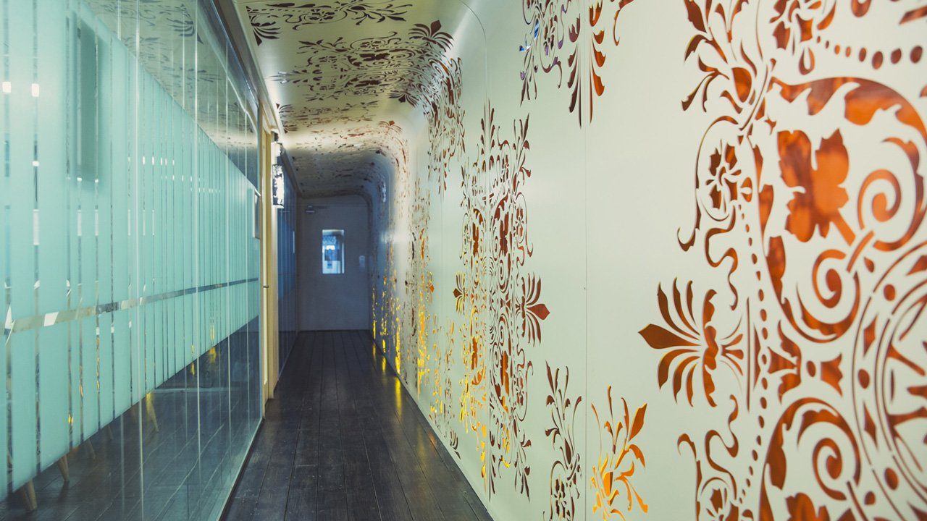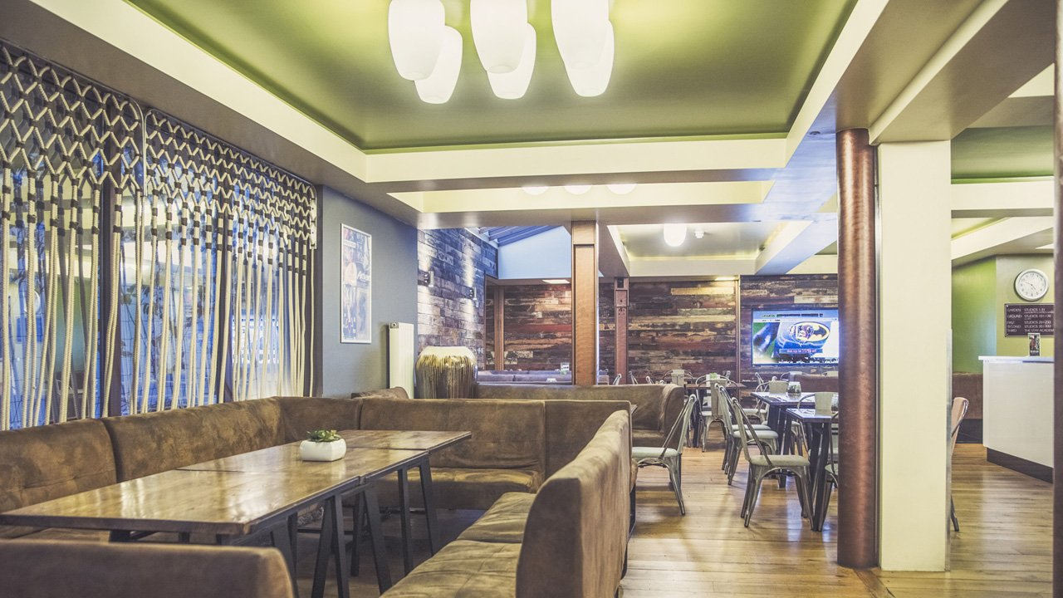

Stay Campus London Willesden — language school in the UK
5J Nicoll Rd, London NW10 9AX, UK, from 10 to 100 age

Course intensity | 15
Accommodation | Residence
Room type | Multi-bedded
Bathroom facilities | En-suite
Meals | Breakfast, Lunch and Dinner
Excursions per week
Weekday excursions
Full day excursions

Description

Why choose this program

Infrastructure

Sport infrastructure

Hobbies and clubs

What else included in the program price

Recommended arrival city

Лондон

Sample timetable
 | Morning | Afternoon | Evening
Day 1 | N/A | ARRIVAL | DINNER
Day 2 | BREAKFAST & LESSONS | HOT LUNCH & FREE TIME | DINNER & DISCO
Day 3 | BREAKFAST & LESSONS | HOT LUNCH & FREE TIME | DINNER & BINGO
Day 4 | BREAKFAST & LESSONS | HOT LUNCH & FREE TIME | DINNER & CINEMA
Day 5 | BREAKFAST & LESSONS | HOT LUNCH & FREE TIME | DINNER & KARAOKE
Day 6 | BREAKFAST & LESSONS | HOT LUNCH & FREE TIME | DINNER & GAMES EVENING
Day 7 | BREAKFAST & FREE TIME | PACKED LUNCH & FREE TIME | DINNER & FREE TIME

Price: €1,070.86

Dates: 2019-08-04 - 2019-08-10

Group leader: Kira Karpova, +7 (920) 661 17 76, kirkar@yandex.ru

