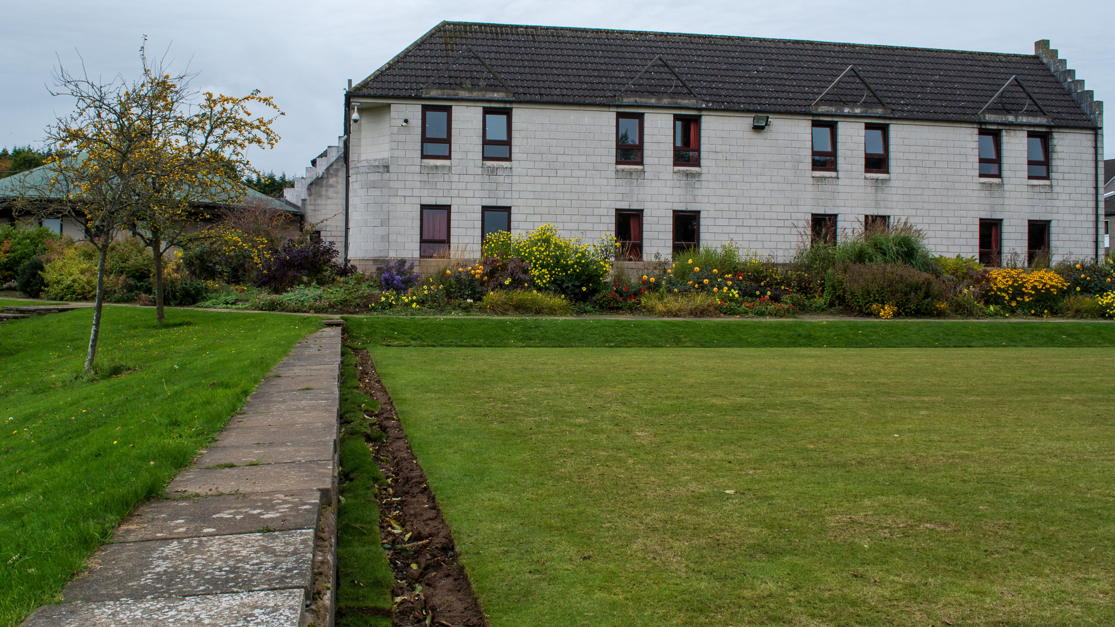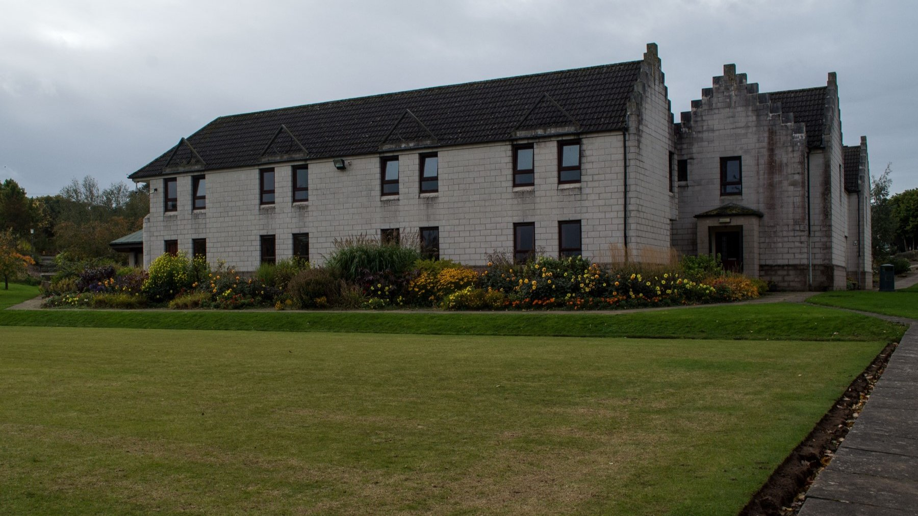

Target Oatridge College Edinburgh — summer school in the UK
Edinburgh, UK, from 10 to 19 age

Course intensity | 15
Accommodation | Campus
Room type | Single
Bathroom facilities | En-suite
Meals | Breakfast, Lunch and Dinner
Excursions per week | 5
Weekday excursions | 3
Full day excursions | 2

Description

Why choose this program

Infrastructure

Sport infrastructure

Hobbies and clubs

What else included in the program price

Recommended arrival city

Эдинбург

Sample timetable
 | Morning | Afternoon | Evening
Day 1 | Test & Induction Lesson | Half-day Edinburgh: Royal Mile & Old Town walking tour | Evening activity
Day 2 | Test & Induction Lessons | Sports, activities and workshops | Evening activity
Day 3 | Lessons | Half-day Edinburgh: Carlton Hill, New Town & Princes Street | Evening activity
Day 4 | Lessons | Sports, activities and workshops | Evening activity
Day 5 | Lessons | Half-day Edinburgh: Edinburgh Castle | Evening activity
Day 6 | Full-day excursion to Stirling, Kelpies, Loch Lomond & Cruise | Full-day excursion to Stirling, Kelpies, Loch Lomond & Cruise | Evening activity
Day 7 | Full-day excursion to St Andrew's Cathedral & Castle via Fishing Villages of Fife | Full-day excursion to St Andrew's Cathedral & Castle via Fishing Villages of Fife | Evening activity

Price: €2,029.23

Dates: 2022-07-03 - 2022-07-17

Group leader: Биркенгоф Дарья Дмитриевна, 89651585791, birkengoff@mail.ru

