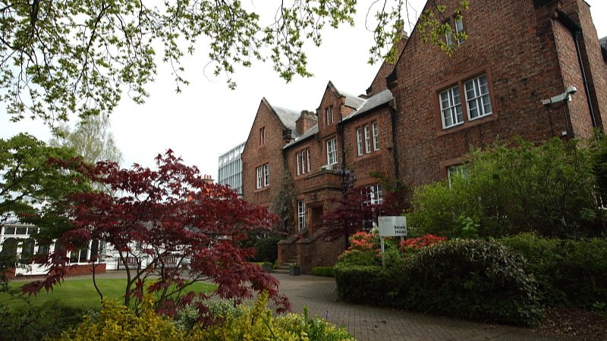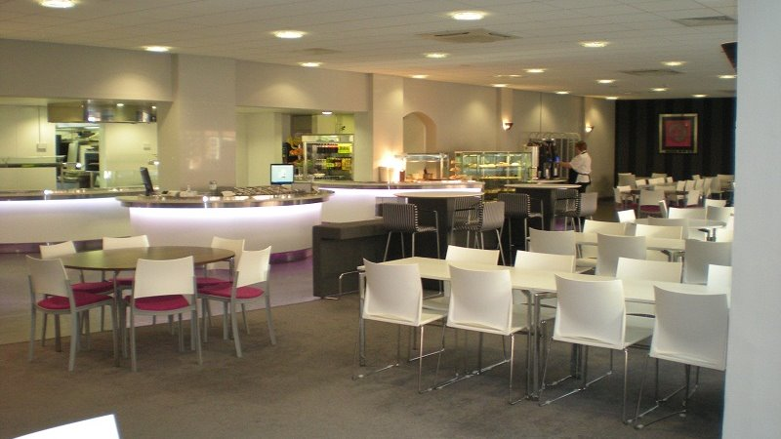

UKLC University of Chester Parkgate Campus — language school in the UK
University of Chester, Parkgate Road Campus, Parkgate Road, Chester, UK, from 11 to 17 age

Course intensity | 15
Accommodation | Campus
Room type | Single
Bathroom facilities | En-suite
Meals | Breakfast, Lunch and Dinner
Excursions per week | 3
Weekday excursions | 2
Full day excursions | 1

Description

Why choose this program

Infrastructure

Sport infrastructure

Hobbies and clubs

What else included in the program price

Recommended arrival city

Лондон

Sample timetable
 | Morning | Afternoon | Evening
Day 1 | English Test | Multi Activity or Chosen Programme | Message Disco
Day 2 | English Lessons | Chester Orientation & Chester Cathedral | Paparazzi or Conversation Club
Day 3 | English Lessons | Multi Activity or Chosen Programme | Quiz Night
Day 4 | English Lessons | Wales with Conwy Castle | Mini-Olympics or Conversation Club
Day 5 | English Lessons | Multi Activity or Chosen Programme | Karaoke
Day 6 | Liverpool with Beatles Story | Liverpool with Beatles Story | Attractions
Day 7 | Free time, Activities or Optional Excursion | Free Time, Activities or Optional Excursion | Film Night
Day 8 | English Lessons | Multi Activity or Chosen Programme | Multi Activity or Chosen Programme
Day 9 | English Lessons | Chester with Cheshire Military Museum & Roman Tour
Day 10 | English Lessons | Multi Activity or Chosen Programme | Multi Activity or Chosen Programme
Day 11 | English Lessons | Llandudno with Great Orme Tramway
Day 12 | English Lessons | Multi Activity or Chosen Programme | Multi Activity or Chosen Programme
Day 13 | Manchester with City of Manchester Stadium Tour | Manchester with City of Manchester Stadium Tour | Manchester with City of Manchester Stadium Tour
Day 14 | Depart

Price: €904.98

Dates: 2019-07-14 - 2019-07-21

Group leader: Ольга Анатольевна Карпинская, +7 (915) 235 04 30, OAKarpinskaya@yandex.ru

