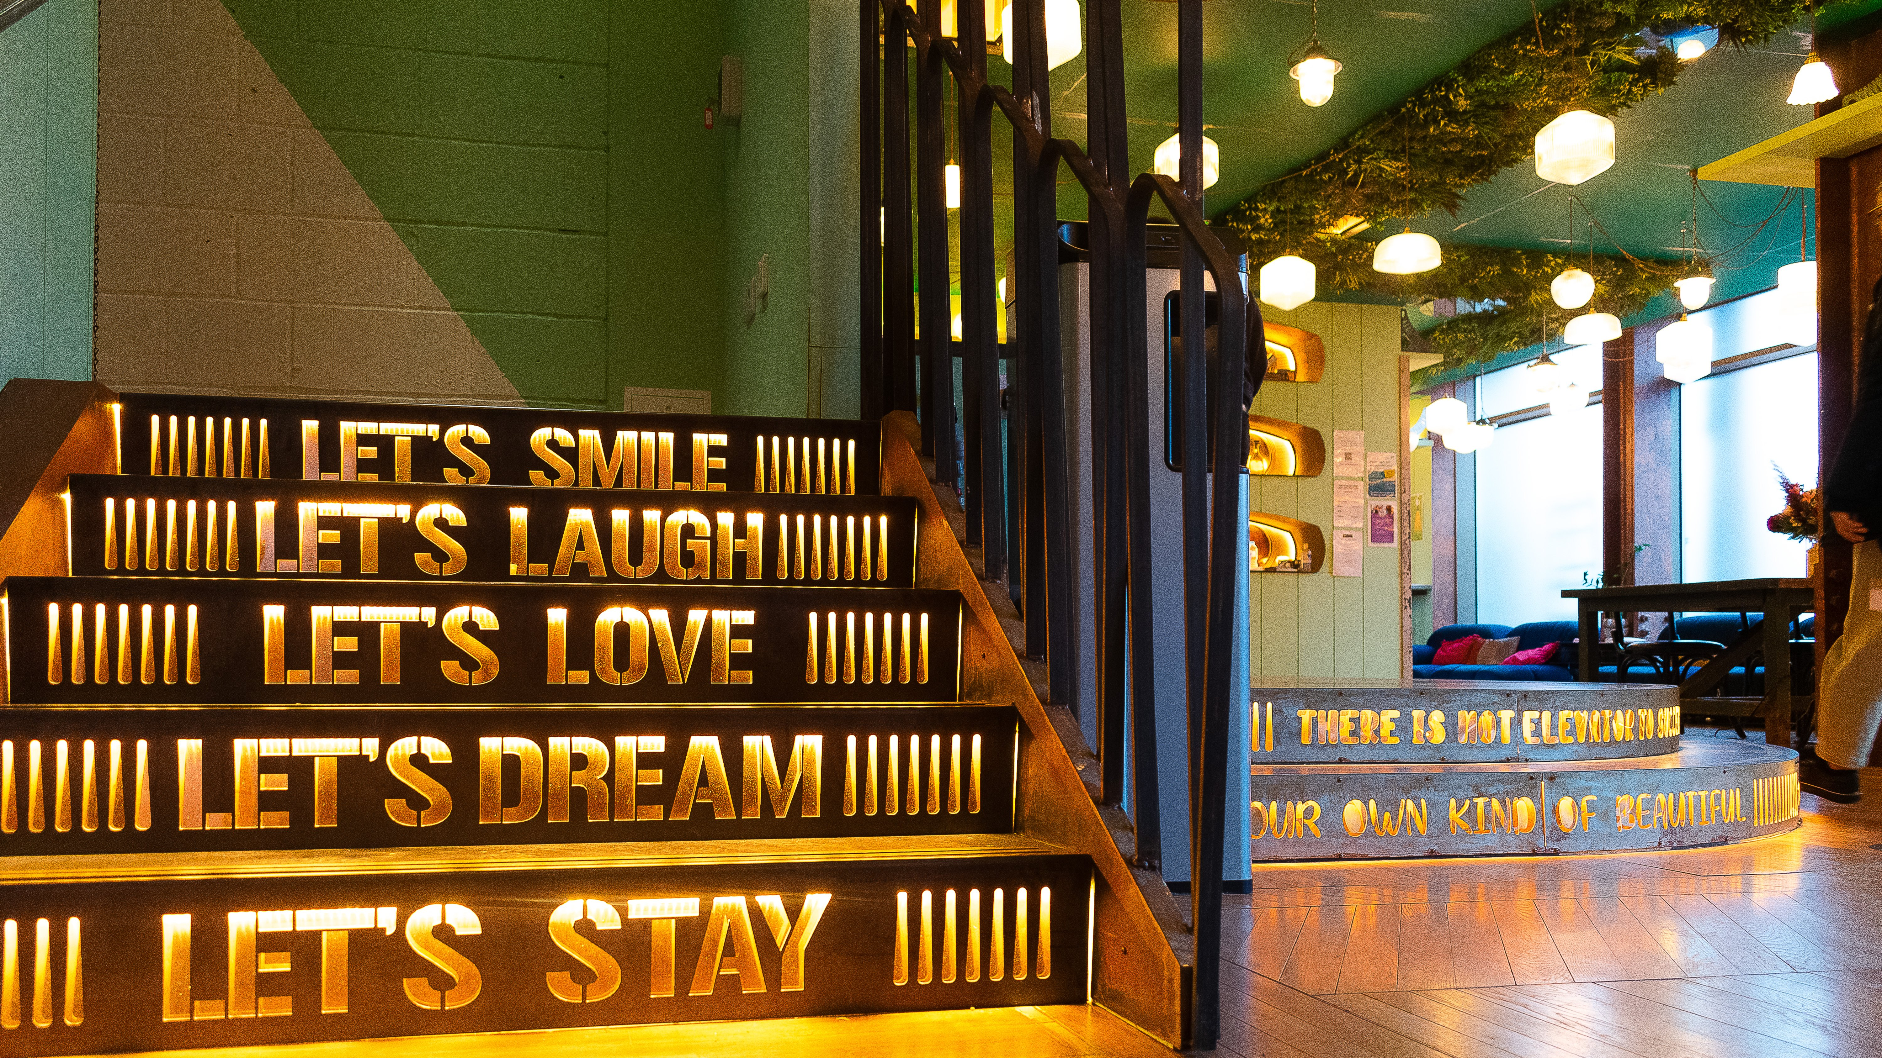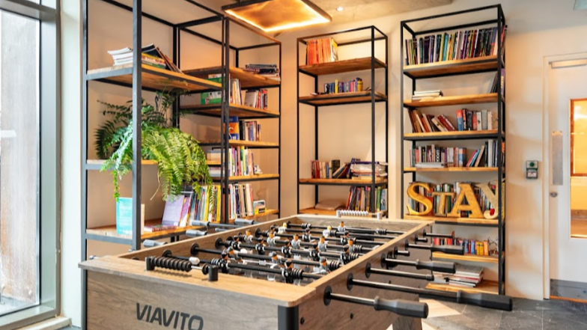

SCL International College North Acton — London language school, UK
200 Western Avenue, London, W3 6FW, from 12 to 17 age

Course intensity | 15
Accommodation | Campus
Room type | Twin
Bathroom facilities | En-suite
Meals | Breakfast, Lunch and Dinner
Excursions per week | 0
Weekday excursions | 0
Full day excursions | 0

Description

Why choose this program

Infrastructure

Sport infrastructure

Hobbies and clubs

What else included in the program price

Recommended arrival city

Лондон

Sample timetable
 | Morning | Afternoon | Evening
Day 1 | N/A | ARRIVAL | DINNER
Day 2 | BREAKFAST & LESSONS | HOT LUNCH & FREE TIME | DINNER & DISCO
Day 3 | BREAKFAST & LESSONS | HOT LUNCH & FREE TIME | DINNER & FREE TIME
Day 4 | BREAKFAST & LESSONS | HOT LUNCH & FREE TIME | DINNER & MOVIE NIGHT
Day 5 | BREAKFAST & LESSONS | HOT LUNCH & FREE TIME | DINNER & FREE TIME
Day 6 | BREAKFAST & LESSONS | HOT LUNCH & FREE TIME | DINNER & GAMES EVENING
Day 7 | BREAKFAST & FREE TIME | PACKED LUNCH & FREE TIME | DINNER & FREE TIME

Price: €786.49

Dates: 2019-06-23 - 2019-06-30

Group leader: , , Lizapazolini@mail.ru

